**八年级（下）英语第16周第2课时**

**总复习（2）写作复习之美好的旅行经历 学习指南**

**【学习目标】**

1. 能够用英文介绍某个地方的基本信息、以及某人的旅游经历和旅游计划。
2. 能够学会电子邮件的写作格式。
3. 能够学会使用开头句、结尾句、主题句等使文章更连贯。

**【学习任务】**

**任务1. 请观看视频，将电子邮件的格式补充完整。**

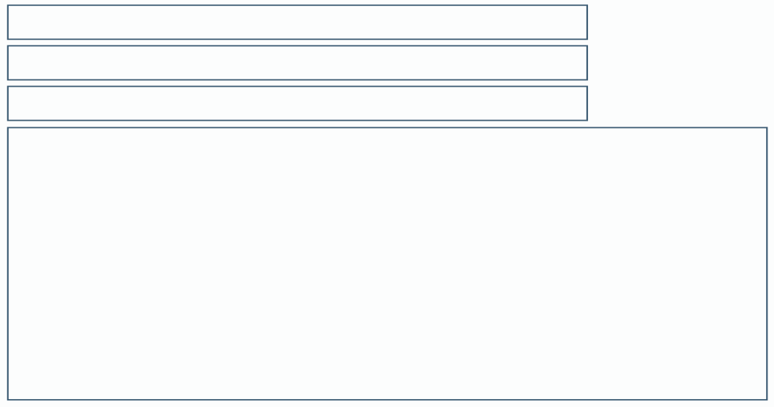

**任务2. 请观看视频，写出回答以下每个问题可以使用的句型或词汇。**

**1）Where is Beijing?**

**_______________________________________________________________________________________**

1. **How large is Beijing?**

**_______________________________________________________________________________________**

**_______________________________________________________________________________________**

1. **What’s the weather like in Beijing?**

**_______________________________________________________________________________________**

**_______________________________________________________________________________________**

1. **What is Beijing famous for?**

**_______________________________________________________________________________________**

**_______________________________________________________________________________________**

1. **What experiences do you have in Beijing?**

**_______________________________________________________________________________________**

**_______________________________________________________________________________________**

1. **What is your plan for the following days?**

**_______________________________________________________________________________________**

**_______________________________________________________________________________________**

**任务3. 观看视频，用适当的词填空。**

* **我们可以在文章中加入____________ 和_____________使得文章更连贯，成一个整体。**

**任务4. 假如你是Lucy,你正在参加学校组织的社会实践活动，你们计划在上海市游览学习四天，现在是到上海的第二天，应爸爸妈妈的要求，你要给他们写一封邮件讲讲自己的所见所闻，邮件的内容包含上海市的基本信息、你的旅行经历、以及你接下来两天的计划。(提示问题见视频）**

**_______________________________________________________________________________________**

**_______________________________________________________________________________________**

**_______________________________________________________________________________________**

**_______________________________________________________________________________________**

**_______________________________________________________________________________________**

**_______________________________________________________________________________________**

**_______________________________________________________________________________________**