**《图形的运动（一）、数据收集整理、克和千克复习》学程拓展**

1.把图形A向右平移4格后得到的图形图上颜色。

|  |  |  |  |  |  |  |  |  |  |  |  |  |  |  |  |  |
| --- | --- | --- | --- | --- | --- | --- | --- | --- | --- | --- | --- | --- | --- | --- | --- | --- |
|  |  |  |  |  |  |  |  |  |  |  |  |  |  |  |  |  |
|  |  |  |  |  |  |  |  |  |  |  |  |  |  |  |  |  |
|  |  |  |  |  |  |  |  |  |  |  |  |  |  |  |  |  |
|  |  |  |  |  |  | A |  |  |  |  |  |  |  |  |  |  |
|  |  |  |  |  |  |  |  |  |  |  |  |  |  |  |  |  |
|  |  |  |  |  |  |  |  |  |  |  |  |  |  |  |  |  |
|  |  |  |  |  |  |  |  |  |  |  |  |  |  |  |  |  |

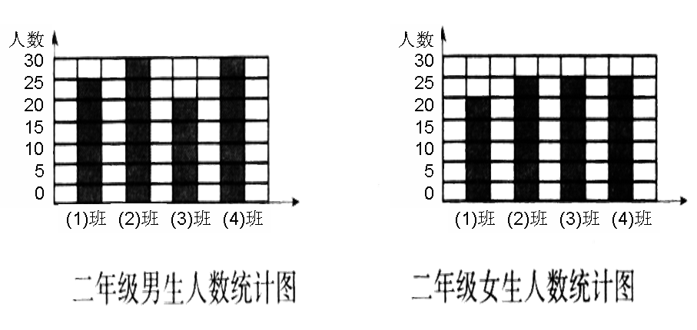2.下面是二年级四个班男、女生人数的统计图，请根据统计图完成统计表，并回答后面的问题。

二年级男生人数统计图 二年级女生人数统计图

|  |  |  |  |  |
| --- | --- | --- | --- | --- |
|  | 二（1）班 | 二（2）班 | 二（3）班 | 二（4）班 |
| 男 |  |  |  |  |
| 女 |  |  |  |  |

（1）男生同样多的班是（ ）班和（ ）班，女生同样多的班是（ ）班和（ ）班。

（2）（ ）班和（ ）班的学生人数同样多。

（3）二（3）班比二（2）班少（ ）人。

3.一桶水连桶重12千克，倒出一半水后，桶和水共重7千克，水桶重多少克？

7KG

12KG