**8年级（下）英语第14周第3课时**

**专项复习2 阅读理解之猜测词义 学程拓展**

1. 同学们，点开下面的1个链接：

https://www.bilibili.com/video/av23486964

你会了解到关于如何掌控你的自由时间的一些小方法。

1. 同学们，让我们一起来读一读下面这篇文章，看看你能了解多少？你又从中学到了哪些单词呢，快积累下来吧！

Take control of your own mind

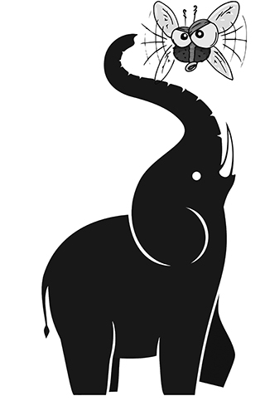Do you listen to music or watch TV when you are doing your homework? Can you focus on (集中精力) just one thing at a time?

An elephant was standing and picking leaves from a tree. A small fly came, flying and buzzing near his ear. The elephant waved it away with his long ears. Then the fly came again and the elephant waved it away once more.

This happened several times. Then the elephant asked the fly, “Why are you so restless and noisy? Why can’t you just stay in one place?”

The fly answered, “I am interested in whatever I see, hear or smell. My five senses, and everything that happens around me, pull me in all directions and I cannot **resist** them. What is your secret? How can you stay so calm and still?”  
 The elephant stopped eating and said, “My five senses do not rule me. I am in control of myself – my senses do not tell me what to do. This helps me stay focused on whatever I do, and so, keep my mind calm and still. Now that I am eating,   
 I am completely enjoying eating.

In this way, I can just focus on enjoying my food.”  
 After hearing these words, the fly’s eyes opened wide and a smile appeared on his face. He looked at the elephant and said, “I understand! I will always be restless if I let my senses control me. On the other hand, if I try to use some self-control, my mind will become calm and I’ll be able to stay still.”  
 It is said that the mind is restless and pays attention to whatever is in front of it. But if you can control what you pay attention to, you can control your mind.