**八年级（下）英语第15周第4课时**

**《期末复习之词组篇》学程拓展**

**The Benefits Of Having A Hobby**

**Improve Your Physical Health.** Hobbies can keep us moving, this activity helps us to stay fit and keeps us busy. Active hobbies don’t have to be strenuous(紧张的), hobbies like walking, hiking, skiing, swimming, boating and the like can be done at a slow medium or fast pace. What’s more when you are enjoying your hobby it doesn’t feel like an exercise chore!

**Improve Your Mental Well-Being.** Studies have shown that having a hobby enables chemical reactions in your brain that can help you stay away from the onset(攻击)of mental illness for some people. Hobbies will also heighten your mental alertness(警觉)and concentration and certainly the completion of a project is great for one’s self-esteem.

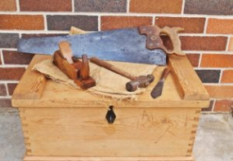**Improve Imagination.** Participating(参与) in a hobby opens up new ways of thinking and helps us become more creative. When you are building that wood working project for instance(例如)and suddenly you have an idea about how it could be tweaked(调整) to make it even better.

**Lessen Anxiety.** A hobby distracts(分散)you from those everyday challenges and tensions. A hobby helps your thoughts change into positive ones and lessens stress levels.

**Build Up Your Interactions.** A shared hobby or interest gives you a sense of common purpose that can be shared with others. These relationships are important and help creating friendship.

**Develop Your Career(事业).** It might seem counter intuitive(反直觉的)that spending time on your hobby can improve your career, however, a hobby can develop your unknown skills that you never realized you had things like problem solving, designing, communication and other important abilities for a successful career.

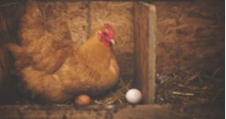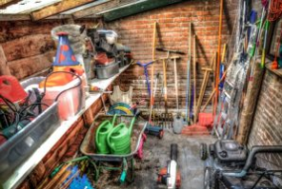**Assist The Move Into Retirement(协助退休).** How many times do we hear of people retiring then having nothing to do once they have left the work force? A hobby or two can replace that sense of purpose lost after retiring from employment.

**Provide Extra Earnings.** Some hobbies can go on to earn extra money while that might not be the original objective, who knows? Building that chicken coop(笼子) may lead you to selling eggs to the neighbors!!!

(*From: http://thehobbysite.com/*)