**八年级（下）英语第15周第4课时**

**《期末复习之词组篇》学习指南**

**【学习目标】**

1. 能够在写作中罗列出相关的词组并正确运用词组回答问题。
2. 能够在阅读中辨析词组或释义词组。
3. 能够运用词组复习方法巩固学过的八下词组。

**【学习任务】**

**任务1：The use of phrases in writing—list some phrases and make sentences to answer the questions.**

1. Topic one: Friendship (an important person)

(1) Who is your best friend? (2018 & 2020) Who is an important person to you? (2019)

___________________________________________________________________________________________

(2) How did your friendship start?(2018) What happened between you and him/her?(2019)

What did you do to help him / her?(2020)

___________________________________________________________________________________________

(3) What do you think of friendship? (2018 & 2020)

___________________________________________________________________________________________

2. Topic two: Hobbies

(1) What’s your favorite hobby? (2019) What’s your name and hobby? (2020)

___________________________________________________________________________________________

(2) How do you keep your hobby? (2018)

___________________________________________________________________________________________

(3) What benefits can you get from your hobby? (2018) Why do you want to be a presenter? (2020)

___________________________________________________________________________________________

3. Topic three: Future plans and activities

(1) When and where are you going to meet? (2019)__________________________________________________

(2) What are you going to do there? (2019)

___________________________________________________________________________________________

(3) What do you advise Peter to take? (2019)_______________________________________________________

**任务2：The use of phrases in reading**

Read and choose the correct answer. (From the clozes in the final exams from 2018 to 2020)

1. “ I want to climb the stonewall,” I said.

“You will hurt yourself!” Grandma cried.

... But when I turned to leave, my grandfather stopped me..., “Let the boy climb the stonewall. He has to ____ things for himself. ” (2018完型）

A. learn to do B. stop to do C. forget to do D. remember to do

2. He ____ sports in our class. He usually won at everything. (2019完型）

A. was bad at B. was angry at C. was good at D. was surprised at

3. ...I stumbled and fell.... He stopped, ____ and helped me up—just as the other pair crossed the finish line. (2019

完型）

A. broke down B. lay down C. moved down D. reached down

4. She believes in me. I knew it was time to ____ my shy cloak. (2020完型）

A. throw off B. keep off C. knock off D. call off

5. ...our class is going to perform a play. “I need someone to ____ Dorothy.” she said. (2020完型）

A. read the lead of B. fight the lead of C. provide the lead of D. play the lead of

Translate the phrases. (From the readings in the final exams from 2018 to 2020)

1.catch a cold________ 2.fight the cold________ 3.get over the cold________ 4.beat the cold ________

5.be great at ___________ 6.feel rested ___________ 7.comfort sb. ___________ 8.make it ___________

9.make sb.do...________ 10.keep doing ________ 11.keep...from doing_________ 12.stop...from doing_______

**任务3：How to review the phrases**

1. Use the textbook to review the phrases.

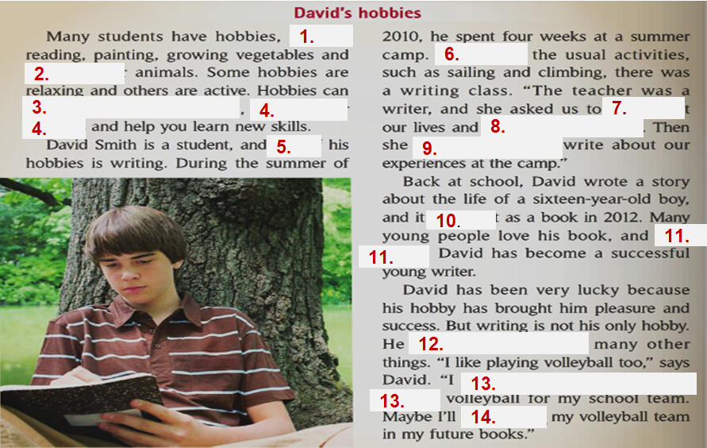

2. Use the *Mubiao* to review the phrases. (Complete the sentences.)

(1) 我害怕和陌生人说话。 I ____________________________speaking to strangers.

(2) 我们以中国为荣。 We _____________________________________ China.

(3) 阿拉伯语在许多方面与英语不同。 Arabic ______________________________ in many ways.

(4) 在非洲，开罗是最大、最繁忙的城市之一。 Cairo ______________________________ cities in Africa.

(5) 刚才妈妈让我帮她洗碗。 Mum _______________________ with the dishes just now.

3. Use the exercises in the textbook or other exercise books to review the phrases.

(Choose a phrase and use its proper form to complete the sentence.)

|  |
| --- |
| be patient with stay in touch regret doing take part in make friends with |

(1) The students_____________________________________ different kinds of activities after class.

(2) We _____________________________________ during the last summer holiday.

(3) She _____________________________________ her students.

(4) I don’t _______________________________ her what I thought.

(5) Would you like to _____________________________________ me?

**任务4：Practice**: **List some phrases, then make sentences with them to answer the questions.**

假如你是李华，你的学校要举行主题为“My Best Friend”的英语征文活动。请你用英文介绍你最好的朋友，包括他（她）的外貌或者性格特点，你经常和他（她）一起做什么并分享一件你们共同经历的事情以及你的感受。



**扫码查看答案**

提示词语: humor, popular, strong, helpful, play football, relax, excited, special

提示问题: ●What is your best friend like?

●What do you often do together?

●Share one memory of something you did together and describe your feelings about it.

**My Best Friend**

*We all need friends in life and the memory of something we did together is still clear in my mind._*___________