**八年级（下）英语第11周第1课时**

**Module 10 Unit 1 学习指南**

**【学习目标】**

1. 能够通过观看微课，了解广播节目和广播站相关知识；
2. 能够简单谈论自己喜欢收听的广播节目；
3. 能够通过听广播节目、对话和独白，获取信息；
4. 能够明确实现梦想的基本途径。

**【学习任务】**

**任务1：观看微课视频，听录音，回答以下问题。**

1. What does he think of listening to the radio? ___________________________________________________
2. What programme does he often listen to? ___________________________________________________
3. What can he learn from the programme? ___________________________________________________

**任务2：观看微课视频，听广播节目1，完成以下句子。**

1. In China, officials ___________ an eleven-week lockdown in Wuhan.
2. In Spain, Health officials say more than 700 people _____________ over the past 24 hours.
3. The leaders of Liberia and Ethiopia declare a state of emergence to help____the spread of the new coronavirus.

**任务3：谈论你喜欢的新闻类型并说明原因。**

What types of news do you like best? Why？

______________________________________________________________________________________________________________________________________________________________________________________

**任务4：观看微课视频，听广播节目2，选择最佳选项。**

1）Where is the speaker?   A. At school.  B. At the radio station. C. On TV.

2）What does the speaker do?   A. A teacher.  B. A presenter. C. A director.

3）What is the speaker mainly talking about? A. Thanksgiving Day. B. Christmas Day. C. Halloween

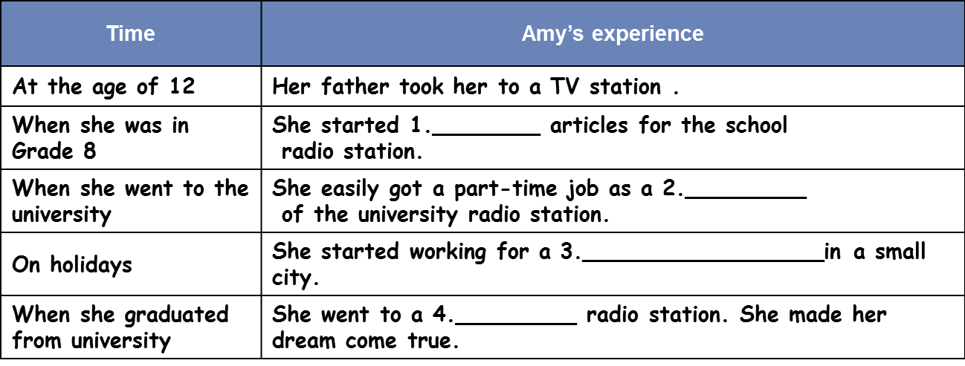**任务5：观看微课视频，听录音，完成表格。**

**任务6：中学生李明喜欢听广播。他梦想大学毕业后到中国国际广播电台做主持人。请录制视频或者音频给他一些建议，帮助他实现梦想。**

**____________________________________________________________________________________________________________________________________________________________________________________________________________________________________________________________________________________________________________________________________________________________________________**