**八年级（下）英语第11周第3课时**

**Module 10 Unit 3学程拓展**

**RADIO DIARIES— THE TEEN REPORTER**

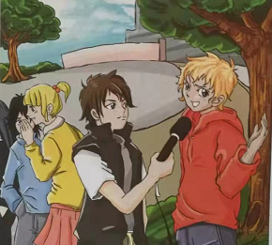 **Joe Richman**

In 1996, Joe Richman had been working as a radio reporter on US national radio for several years and was looking for a new idea for a radio programme. He met a teenager called Josh Cutler. Josh had Tourette’s Syndrome— a brain disorder. This meant that Josh did not always have control of his movements and speech. *Josh was recording at school*

Josh was just beginning high school when he agreed to work with Joe on a story about his illness. Joe wanted Josh to keep a radio diary of his daily life. He gave Josh a tape recorder and asked him to record what happened to him every day. Josh and Joe agreed that an important part of his story would be talking to his school friends about Tourette’s Syndrome. Josh was embarrassed to record at school— his friends might laugh.

One day, Josh took the tape recorder to school, but he kept it inside his bag all day. He was too afraid to bring it out. After months of feeling afraid, he took the tape recorder out one lunchtime. What happened next was a total surprise. Josh tells it best: “ Everyone jumped at the chance. Everyone started asking me questions about Tourette’s. It was weird because, before that, I had never really talked about it to anyone— except my mom and dad.”

That was an important day in Josh’s life because he learned to be more open about his condition. Now Josh says he wants to do radio diaries until he’s 80 years old. He learned a lot about himself by doing the radio diary. It made a great radio programme, too. Being a reporter is like having a passport. You can ask questions, be curious and explore new worlds. Radio is the perfect way to do all of this because everyone wants to be on the radio and everyone likes to listen!