**八年级（下）英语第10周第4课时**

**Module 9 Revision 学习指南**

**【学习目标】**

1. 能够运用本节课重要语言点及词汇表达完成关于友谊的调查问卷；
2. 能够借助调查问卷及拓展材料，完成关于友谊的写作练习。

**【学习任务】**

**Task 1** Choose two pieces of proverbs you like most and write them down .

If you like, you can draw some beautiful pictures for them and color them.

|  |  |
| --- | --- |
| 1. | 2. |

**Task 2 Complete the form: use what you’ve learned in this module and your own ideas**

|  |  |  |  |
| --- | --- | --- | --- |
| **Check Yourself** | **What you find from the text** | **More information** | **Your ideas** |
| **Can you tell us how to describe the importance of friendship?** |  |  |  |
| **Can you tell us how to start friendship?** |  |  |  |
| **What may be the problems between friends?** |  |  |  |
| **Can you tell us how to be a better friend?** |  |  |  |

**Task 3 Writing**

最近，21世纪英语报社接到很多青少年同学的来稿，诉说他们交友的困扰。为此，该报社组织了一次以“友谊”为主题的征稿活动，希望为这些同学带来帮助。假如你是李华，请写一篇短文投稿，介绍友谊的重要性，如何展开一段友谊以及如何成为更好的朋友。

提示问题：1. Is friendship important for teenagers? Why?

2. Can you tell us how to start a friendship (how to make a friend)?

3. Can you tell us how to be a better friend?

Everyone needs friends. There is an old saying “_______________________________________________.”

Friendship brings us something ___________and ______________. And it can make us ______________.

To make a friend, you cannot be shy. You should _____________________. Even the best friends have fights. If you have fights or problems with your friend, you need to _________________________________________.

Here is some advice on being a better friend. First, _____________________________. Second, ___________________________________. At last, _____________________________.

In short, good friendship will just not easily last. You must give as much as you take, or friendship will die away.

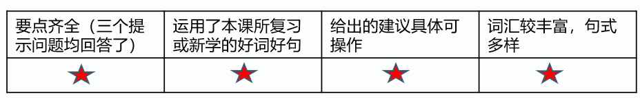

How many stars can you get for your work? _______________________