**八年级（下）英语第12周第4课时**

**《名著简介》 学习指南**

**【学习目标】**

1. 能够通过阅读An introduction to *Treasure Island*归纳出写名著简介的基本要素为：作者、作品背景、主要人物、起因、经过、结果、个人观点等;
2. 能够获取、梳理、概括教材所选名著简介中主要信息和细节信息;
3. 能够根据事实依据分析、归纳人物性格特征。

**【学习任务】**

**任务1：Know something about the background of *Treasure Island.***

**A. Watch 3 short films and answer the questions.**

1. What can you see on the ship? ________________________________

2. What are the men on the ship? ________________________________

3. What do they look like? ________________________________

4. Why did pirates want to go to the Treasure Island?

_________________________________________________________

5.What was the most important clue for the survival pirates?

_________________________________________________________

**B: Write down the main characters.**

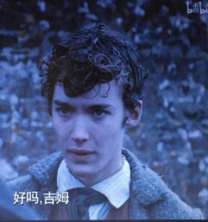 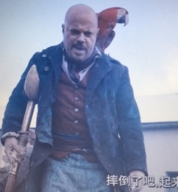 

**________________ ________________ __________________**

**任务2：Main events**

**A: Read and answer the questions.**

1. Why do Jim Hawkins and his friends buy a ship?

____________________________________________________

2. Who are the people that work on the ship?

____________________________________________________

3. Why does Jim follow the pirates on the island?

____________________________________________________

4. Why do the pirates not find the gold?

____________________________________________________

5. Why do Jim and his friends take Long John Silver with them when they leave the island?

____________________________________________________

**B: Number the main events in sequential order.**

□a. Jim and his friends buy a ship to go to the island to look for the gold.

□b. Although the pirates take the map and find the place, there is no gold there because of Ben Gunn.

□ c. When Jim and his friends get back to England, Jim decides never to go looking for gold again.

□d. They discover Long John Silver and the other men on the ship are all pirates when they set sail.

□e. Ben agrees to share with Jim because they will take him back to England.

**□**f. Jim and his friends fight as soon as they get to the island.

**任务3: Retell the introduction to Treasure Island!**

1. Setting：

Tell the writer and when and where

2. Characters：

Who are in the story?

3. Problems

What is the problem?

4. Order of events

Tell the story in order: 1, 2, 3

5. Problem solved

How is the problem solved?

6. Opinions

Would you like to read it? Why or why not?

**任务4：Analyze the characteristics of the main hero.**

**Jim Hawkin**s:

**The facts:**

1. The pirates are planning to kill them. As soon as they get to the island, Jim and his friends fight the pirates.
2. The pirates go to look for the gold, and Jim follows them.

**The characteristics:** _______________________________________________________

1. Later, Jim knows it is because of Ben Gunn.
2. When they get back to England, Jim decides never to go looking for gold again.

**The characteristics:** _______________________________________________________

**Summary：** Jim is .

**Homework:**

Write about a book you have read or a film you have seen.