**8年级（下）英语第3课时（第10周）**

**《Module 9 Grammar》学习指南**

**【学习目标】**

1. 能够辨别并能正确使用宾语从句三类引导词(that, question words, if/whether)；
2. 能够根据主句时态和语境在宾语从句中运用合适的时态表达。

**【学习任务】**

任务1：填空“宾语从句用法口诀”

学习宾从三注意：时态、语序、引导词

主句若为现在时，从句时态________________;

主句若为过去时，从句____________________。

_______引导陈述句，省与不省没关系；

特殊疑问做宾语，仍用________________，语序要用________________;

从句若表是否时，_______________均可以。

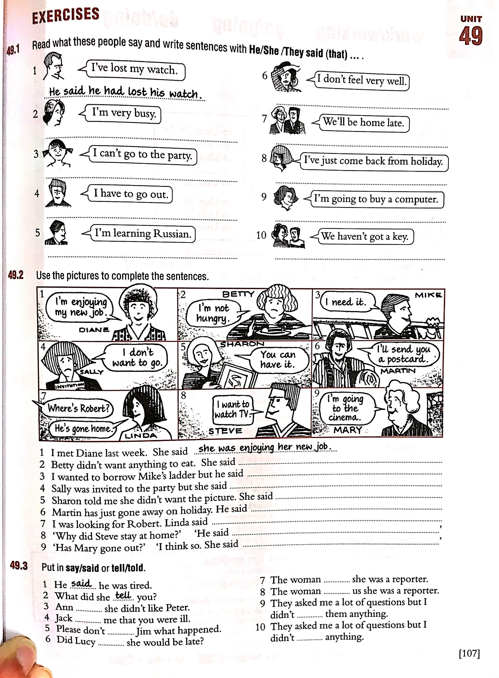**任务2：**Use the pictures to complete the sentences.

1. I met Diane last week. She said she was enjoying her new job.

2. Betty didn't want anything to eat. She said __________________________.

3. I wanted to borrow Mike's ladder but he said__________________________.

4. Sally was invited to the party but she said __________________________.

5. Sharon told me she didn't want the picture. She said __________________________.

6. Martin has just gone away on holiday. He said __________________________.

7. I was looking for Robert. Linda said __________________________.

8. “Why did Steve stay at home?” “He said __________________________.”

9. “Has Mary gone out？” “I think so. She said __________________________.”