**八年级（下）英语第10周第1课时**

**Module 9 Unit 1 学习指南**

**【学习目标】**

1. 能够理解关于友谊的听力大意并能提取细节信息。
2. 能够创作关于友谊的诗歌。

**【学习任务】**

**任务1：How many “ticks”(√) do you have?**

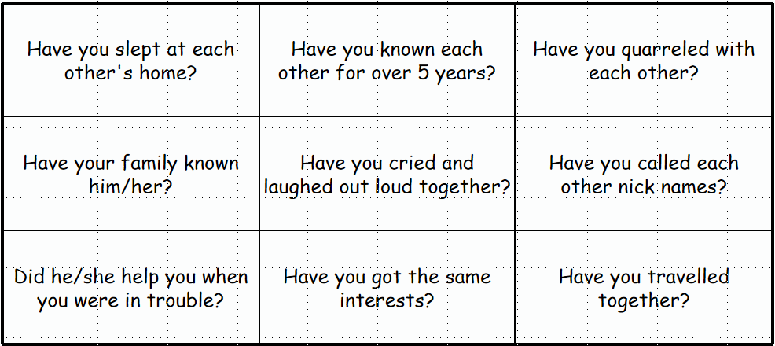

**任务2：What is the conversation about?**

1. A younger brother and his elder brother who doesn't have many friends.
2. A man and a woman who are the same age and are each other’s oldest friends.
3. Differences between relationships on social networks and close friends.

**任务3：Write down the following information about his friend.**

|  |  |
| --- | --- |
|  | Kenny |
| When did they meet? |  |
| Where did they meet? |  |
| What did they like about them? |  |

**任务4：Are the following descriptions true or false?**

1. ____Kenny has a lot of friends on Facebook.

2. ____Kenny's oldest friend Pete lives in the USA.

3. ____They were best men for each other’s wedding.

4. ____Kenny sees Pete very often.

5. ____Kenny named his son after Pete.

**任务5：Put the words in the right order to make sentences about them.**

1.me my job all over the world takes and I make wherever friends I go

2.when we get about together we’re football immediately talking

3.he after named best son his friend his

**任务6：Deeper thinking.**

1. How many close friends are proper? Why?

2. Some people have lots of friends on social networks, but they don't have any friends in their real life. What's your opinion on this problem?