**8年级（下）英语第4课时（第9周）**

**Revision Module 8学习指南**

**【学习目标】**

1. 能够梳理出描写到某一个城市旅游的思维导图;
2. 能够通过观看南宁视频、阅读有关南宁的文章获取描述旅游城市的句型;
3. 能够根据思维导图及句型，写一篇去北京旅行的计划。

**【学习任务】**

**任务1：“玩转旅游攻略”Draw a mind map for a holiday trip to a city.**

The city to travel

**任务2：“南宁知多少”Watch the video and take notes by filling in the blanks.**

**【Descriptions of the city】**

**note-taking:**

1. This is a city of never __________________. It stays ____________ and ________.
2. Actually, as the_______city of Guangxi, Nanning is an _______ city dating all the way back to_______________.
3. So it is an __________________ after all.

**任务3：“南宁我介绍”Read the passage and answer the questions.**

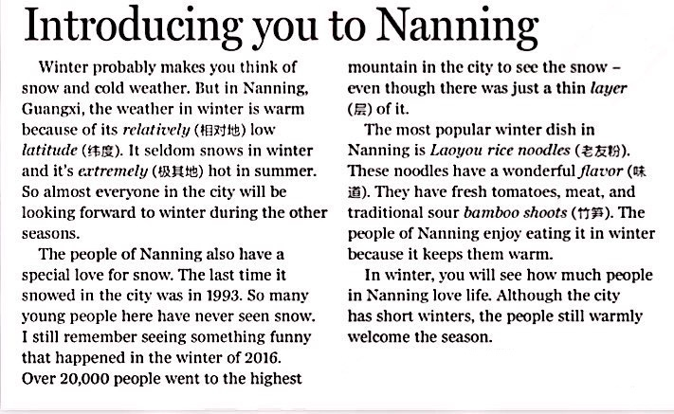

Word Bank:

relatively 相对地

latitude 维度

extremely 极其地

a special love for...

对...特殊的爱

layer 层

flavor 味道

bamboo shoots 竹笋

warmly welcome 热烈欢迎

1. What’s the weather like in Nanning?

_______________________________________________________________________________

1. Why did over 20,000 people go to the highest mountain in the city?

_________________________________________________________________________________

1. What’s the most popular winter dish in Nanning? Why do people enjoy eating it in winter?

_________________________________________________________________________________

**【Description of the weather】**

1. 冬天几乎不下雪并且夏天极度炎热。_________________________________________________

**【Descriptions of the dish】**

1. The most popular winter dish in Nanning is *Laoyou rice noodles*. 用be famous for改写这个句子

__________________________________________________________________________________

1. 这些粉有着极好的味道。____________________________________________________________

**【Description of what people can do】**

1.南宁的人们喜欢在冬天吃老友粉因为它使他们温暖。

____________________________________________________________________________________

**任务4：“Lucy的下一个打卡圣地”**

**Time to write: Help Lucy to make a holiday travel plan in Beijing or Chongqing.**

Beijing

Chongqing

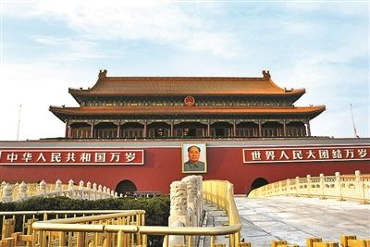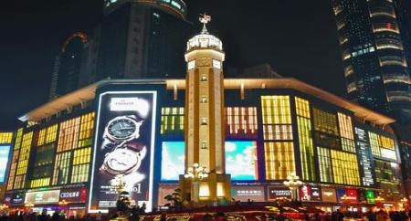You should tell her:

1. Where is it? What’s the city like?
2. What is the city famous for?
3. What can she do there?
4. When is the best time to go there?

*Hi Lucy,*

*I’d like to help you make a holiday travel plan in Beijing.****_*________________________________________**

**_______________________________________________________________________________________________________________________________________________________________________________________________________________________________________________________________________________________________________________________________________________________________________________________________________________________________________________________________________**

**___________________________________________________________________________________________**

**___________________________________________________________________________________________**

**___________________________________________________________________________________________**

**___________________________________________________________________________________________**

*I’m sure you will have a great time in Beijing.*

*Yours,*

*Dora*