**八年级（下）英语第6周第2课时**

**Revision Module A（2）学习指南**

**【学习目标】**

1. 能够在语境中使用感官动词。
2. 能够用英文描述图片中人物生病后的症状。
3. 能够通过复习卡通人物的外貌和个性特征的相关词汇，描述自己喜欢的卡通角色。

**【学习任务】**

**任务1：**

1.Think about the words of feelings and impressions and write them down on the mind-map.

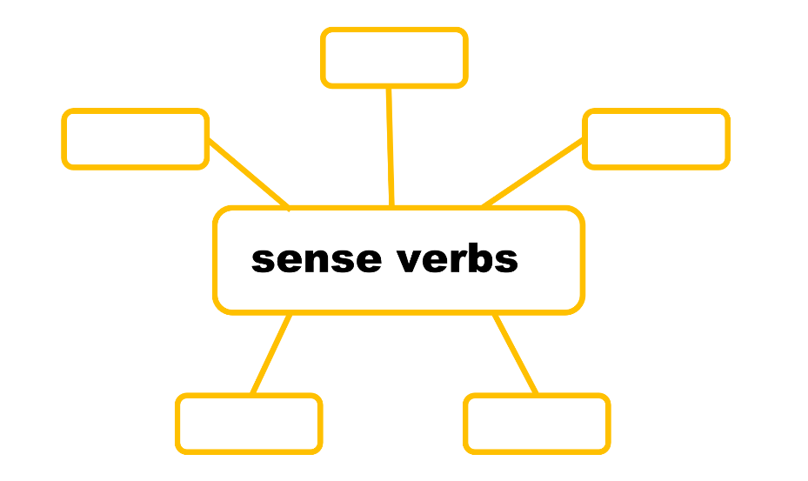

1. Write down the adjectives used after those words.

Look: ______________________________________________________________________

Taste: ______________________________________________________________________

Smell：_____________________________________________________________________

Feel：______________________________________________________________________

Sound：____________________________________________________________________

3. Complete the sentences with correct form of the words in the box.

feel look taste sound smell

Betty and Lingling are working very hard. They look busy.

1.The shoes_______ too small for my feet.

2.Daming does not like the pizza on the table. It does not_________ fresh.

3.The music ________ wonderful!

4.You need to wear a coat. It _______ cold outside.

5.Shrek is friendly but he ________ugly.

6.Lingling is making chocolate cookies. They __________delicious.

**任务2：**

1. Try to describe the Robinsons’ travelling experience with complete sentences using the given phrases.

________________________________________________________________________________

________________________________________________________________________________

________________________________________________________________________________

________________________________________________________________________________

**任务3：**

1. Complete the passage with correct form of the words in the box.

spaceship reach astronaut Mars

Do you want to go to _______? How will you get there? NASA (美国国家航空航天局) has made a new________ – the MPCV. Scientists will use it to explore Mars. The spaceship can _______Mars in six months. It is 5 meters wide and 23,000kg. It carries four ________. Scientists will test the spaceship before it goes to Mars. They are going to let it work in the International Space Station (国际空间站) first.

**任务4：**

1. Think about the symptoms of falling ill and write them down on the mind-map.

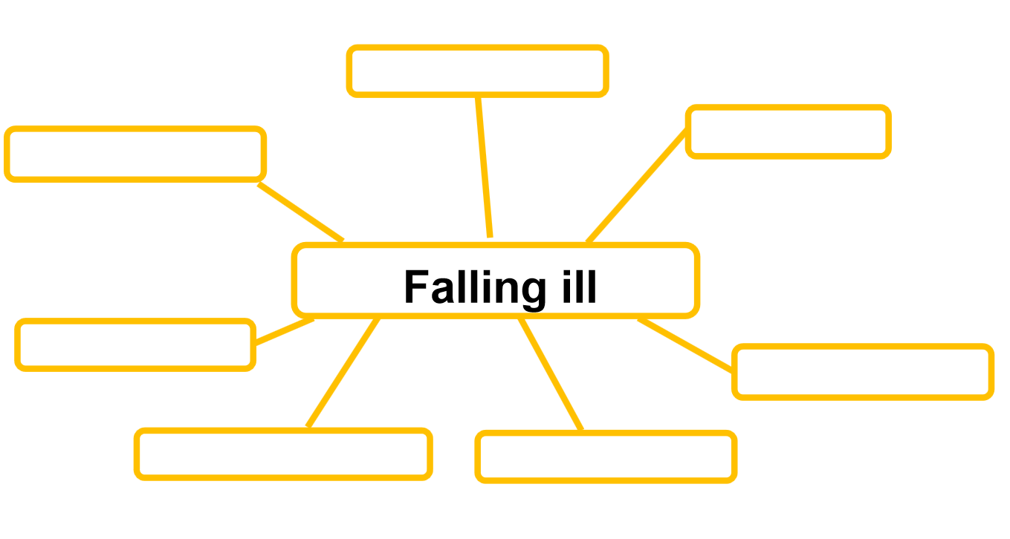

2.Write down the symptoms(症状) of the people in the picture.

________________________________________________________________________________

________________________________________________________________________________

________________________________________________________________________________

________________________________________________________________________________

**任务5：**

1. Write down a short passage about your favorite cartoon character. It should include the description of the character’s appearance and personality and the reasons why you like it.

________________________________________________________________________________

________________________________________________________________________________

________________________________________________________________________________

________________________________________________________________________________