**8年级（下）英语第2课时（第9周）**

**Module 8 Unit 2 学情拓展**

**Travel tips for Finland**

We have selected some of the most useful Finland travel tips that tourists have provided over the years to help you make the very most of your holiday - and the space inside your suitcase.

“Batteries die really quickly out there so be sure to take quick photos and then hide the camera until needed again. A spare battery is cost effective.” **- Damian Clithero**

“Take head torches if you go in winter, as it gets VERY dark. The food was very good - they coped far better with my seafood allergy than any other holiday I have been on and provided a good variety of vegetarian meals.” **- Karen Horridge**

“A set of thermal underwear is essential. Don’t take wet wipes as they freeze solid.” **- Susan Prcychodny**

“Have an open mind and go with the flow! I abandoned my quasi vegetarian diet for the week and found reindeer to be much more delicious than I had imagined.” **- Emma Davey**

“Finnish Sauna includes bucket showers - so don't forget your shower gel. It is an exceedingly pleasant way to end the day.” **- Selina Bolton**

“Just go for it - you don't know what you are capable of until you try it. Snowmobiling, snowshoe walking and dog sledding at the age of 62 was very special.” **- Pam Crosland**

“Approach everything with enthusiasm. You will get far more from activities and the people running them if you show an interest, are prepared to give anything a go and involve yourself as much as possible.” **- Elizabeth Johnston**

* How many pieces of advice are mentioned in the passage? Can you summarize them with a mind map?
* 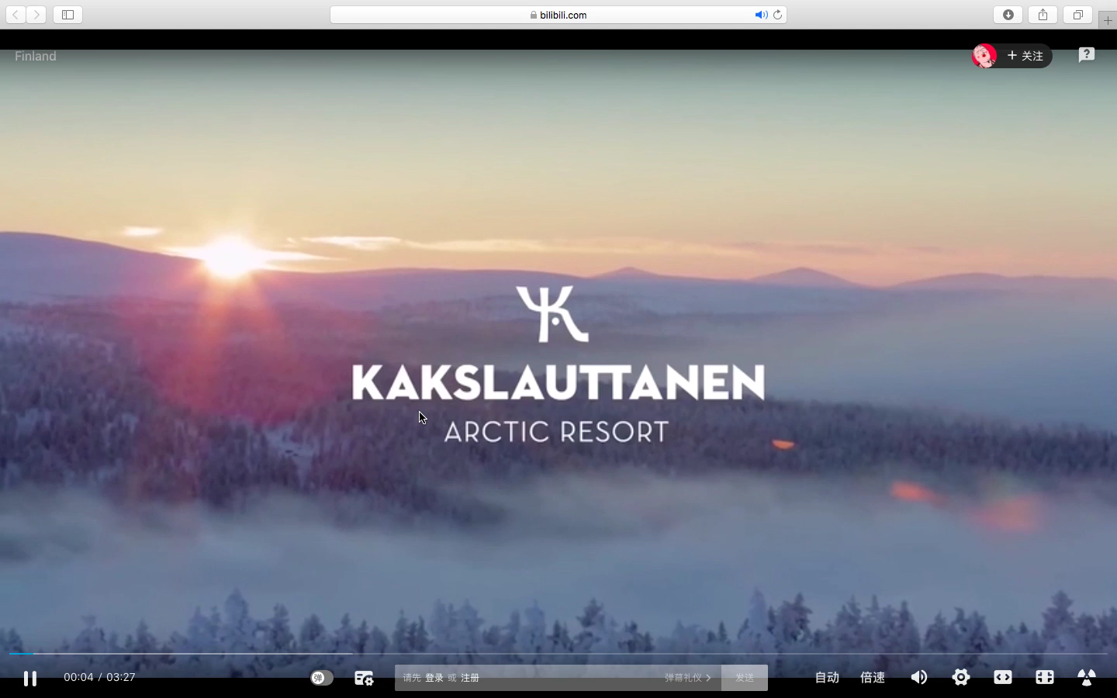If you want to know more about Finland, please watch this video: