**8年级（下）英语第2课时（第9周）**

**Module 8 Unit 2 学习指南**

**【学习目标】**

1. 能够通过阅读游记梳理芬兰旅行的相关信息；
2. 能够利用获取的细节信息介绍芬兰。

**【学习任务】**

**任务1：**

**Look at the pictures and answer the following questions:**

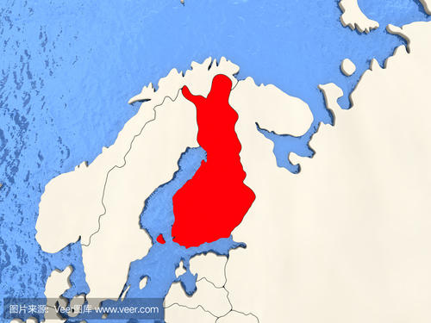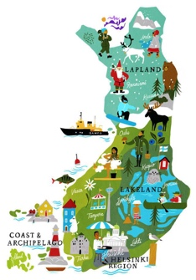 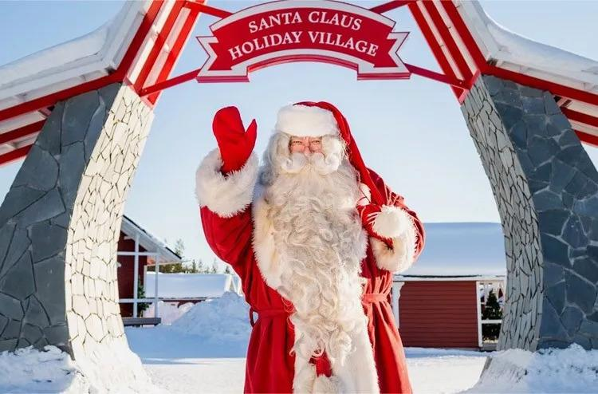 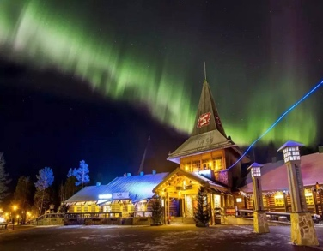

Which country is it?

_____________________________.

What information will we get from the passage?

_____________________________.

**任务2：**

**Read the passage and answer the questions below:**

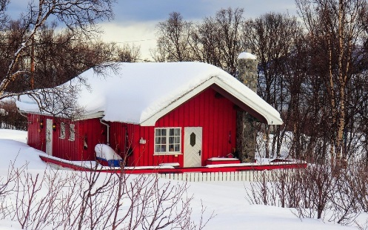Finland offers plenty of things that make you pack your bags not with souvenirs, but a bag full of precious（珍贵的）memories from this Nordic（北欧的） country.

On the last evening, I went to glide（滑行、滑翔）. As I glided through the white forest, I sank into the mood completely, closing my eyes, feeling the freezing wind traveling through my body. I wished that I could come back again to this winter wonderland.

I still remember the very first look of the dreamy winter wonderland from my room’s window, early in the morning. I saw a wooden house half buried（埋） in white snow across the road. It was nothing less than a fairytale（童话的） world.

Without wasting even a second, I decided to take a walk around. To my surprise, when I checked the local time, it was 9 a.m. and it was dark outside. With the special landscape（地形）, it hardly sees a few hours of daylight（昼、白天） during eight months of winter. Everything moves slowly here because of the short daylight. While walking in the snowy paths, somebody just greeted me by saying,“Welcome to Finland”**.** I stood still（静止地） and kept smiling.

Before I realize, the place kind of grows on me. I started enjoying a few hours of daylight, the beautiful little village and the hot cup of coffee. Going for window shopping and even joining in conversations with the local people, used to be my favorite pastime. Out of all these, what I loved the most was the adventure（冒险） activities such as snowshoeing（雪鞋健行）, skiing, etc. There is a whole new world for people who love to go for adventure activities, food lovers, and even culture experts（专家）.

1. Where is Finland?

____________________________________________________

1. What did the writer see?

____________________________________________________

1. What’s special in Finland?

____________________________________________________

**任务4：**

Find out the writer’s activities in Finland and complete the mind map.

During her stay in Finland

On the first day On the last evening

**任务5：**

**Deep thinking**

Will Jim love his holiday in Finland? Why or why not?

______________________________________________________________________________________________________________________________________________________________________________________

**任务6:**

**Summarize the information about Finland.**

|  |  |
| --- | --- |
|  | Information about Finland |
| Where is it? |  |
| What can you see? |  |
| What can you do? |  |
| What is special? |  |

**任务7：**

Please introduce Finland to Jim according to the information you got from the passage.

____________________________________________________________________________________________________________________________________________________________________________________________________________________________________________________________________________________________________________________________________________________________________________