**八年级（下）英语第5周第4课时**

**Module 5 Revision学习指南**

**【学习目标】**

1. 能够通过操练模块重点句型和复现课文梳理出介绍卡通片的七个方面。
2. 能够通过语境下记忆单词并通过做词性转换来扩充积累词汇。
3. 能够通过对课文时态的总结和时态图示的提示来区分并正确使用一般现在时，一般过去时和现在完成时三种时态并完成对Nemo的扩写。

**【学习任务】**

**任务1：Complete the passage with the words in the box.**

create laugh mess own private satisfy ugly

Many people love cartoons because they are great fun. Parents and children (1) ______ together as the Monkey King makes a terrible (2) _______ or Shrek, the (3) _____ green man, sings a song. Cartoon heroes often live in a(n) (4) _______ world of their (5) ______. Artists (6) ______ good cartoon heroes as well as bad people. The heroes always win, and their stories (7) _______ us and help us feel safe.

**任务2： Complete the conversation with the correct form of the words in brackets.**

Daming: Hi, Tony. What are you reading?

Tony: *The Adventures of Tintin*. It’s fantastic. (1) ______ you _________ (ever read) a Tintin book?

Daming: No, I (2) ________________ (never read) a Tintin story. (3) ______ (be) they popular?

Tony: Yes, they (4) ___________ (be) popular for more than eighty years. The first Tintin story (5) ________ (appear) in 1929.

Daming: What does Tintin do?

Tony: He (6) ______ (work) for a newspaper and he (7) _____ (have) lots of exciting experiences.

Daming: And (8) ______ the stories ______ (have) happy endings?

Tony: Oh, yes, they always do.

Daming: Sounds great! Do you mind if I borrow your book?

**任务3：**

课本上关于Nemo的介绍不全面，通过今天的复习，查阅相关背景资料，扩写Nemo。

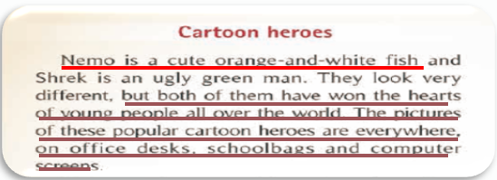

要求：

1. include 7 aspects.
2. use as rich words as possible.
3. use proper tenses.

**____________________________________________________________________________________________________________________________________________________________________________________________________________________________________________________________________________________________________________________________________________________________________________________________________________________________________________________________________________________________**