**八年级（下）英语第2周第4课时**

**Module 2 Revision 学习指南**

**【学习目标】**

1. 能够运用现在完成时的肯定句，否定句及一般疑问句（及回答）介绍并询问个人经历；
2. 能够根据所给情景，运用现在完成时，写出语句流畅，有一定逻辑关系的文段介绍自己的个人经历。

**【学习任务】**

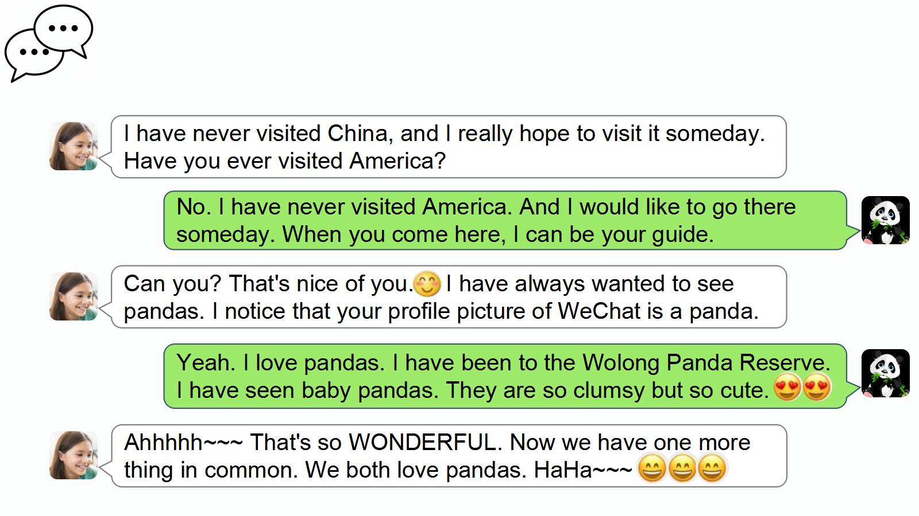**任务1：Please read the WeChat conversation and underline the sentences telling and asking about experiences.**

We use____________________________(tense) to talk about experiences.

The structure is __________________________________________.

**任务2: Please write the pp (past participle过去分词) forms of the following verbs.**

**1.bring______________**

**2.fall________________**

**3.find_______________**

**4.hold_______________**

**5.leave_______________**

**6.pay________________**

**7.buy________________**

**8.speak______________**

**9.teach_______________**

**10.write_______________**

**11.win________________**

**12.spend______________**

**任务3：Design a questionnaire.**

1. Please write down some questions about some interesting, unforgettable or surprising experiences.

|  |  |  |  |  |
| --- | --- | --- | --- | --- |
| **Topics** | **Questions** | **Friend 1**  **____________** | **Friend 2**  **__________** | **Friend 3**  **___________** |
| Transport | *Have you ever rowed a boat?* |  |  |  |
| Book |  |  |  |  |
| Travel |  |  |  |  |
| Sport |  |  |  |  |
| Hobby |  |  |  |  |
| Film |  |  |  |  |
| Game |  |  |  |  |

(2) Ask your friends to take your questionnaire by WeChat or QQ. Please tick their experiences.

(3) Write a short report based on your questionnaire survey. （基于你的调查问卷写一篇简短的报告。）

*Friend 1* has……/ But he/she hasn’t……

___________________________________________________________________________________________

___________________________________________________________________________________________

*Friend 2* _________________________________________________________________________________

__________________________________________________________________________________________

__________________________________________________________________________________________

*Friend 3* _________________________________________________________________________________

__________________________________________________________________________________________

__________________________________________________________________________________________

**任务4：Read and check what Lily has done and hasn’t done in New York.**

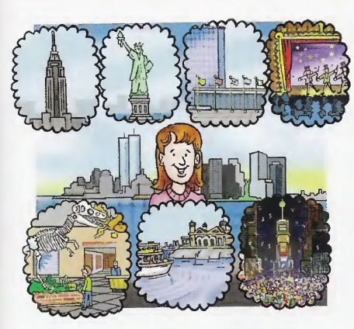 **Lily likes New York**

Lily has lived in New York for a long time. She has done a lot of things in New York. She has been to the top of the Empire State Building, she has visited the Statue of Liberty, she has taken a tour of the United Nations, and she has seen several Broadway shows.

However, there are a lot of things she hasn’t done yet. She hasn’t visited any museums, she hasn’t seen Ellis Island, and she hasn’t been in Times Square on New Year’s Eve.

Lily likes New York. She has done a lot of things, and there are still a lot more things to do.

1. Has Lily lived in New York for a long time or for a few weeks?
2. Has she been to the top of the Empire State Building?
3. Has she visited the Statue of Liberty?
4. Has she taken a tour of the United Nations or Ellis Island?
5. Has she been to Broadway shows or any museums?
6. Has she been in Times Square on New Year’s Eve?

**任务5： Now please write about your experiences in Beijing.**

___________________________________________________________________________________________

___________________________________________________________________________________________

___________________________________________________________________________________________

___________________________________________________________________________________________

___________________________________________________________________________________________

___________________________________________________________________________________________

___________________________________________________________________________________________