**八年级（下）英语第4周第4课时**

**Module 4 Revision 学习指南**

**【学习目标】**

1. 能够通过归纳、总结有关health problems的词汇，形成系统的词群意识，更好地掌握这个主题的词汇；2. 能够在主题情境中理解现在完成时的意义，使用现在完成时的结构描述有关健康的问题，并针对问题提出相应的建议；

3. 能够结合复习内容与自己的实际迁移创新，写出自己的锻炼情况并给他人提出一些健康生活的建议。

**【学习任务】**

**任务1：Finish the mind map.**

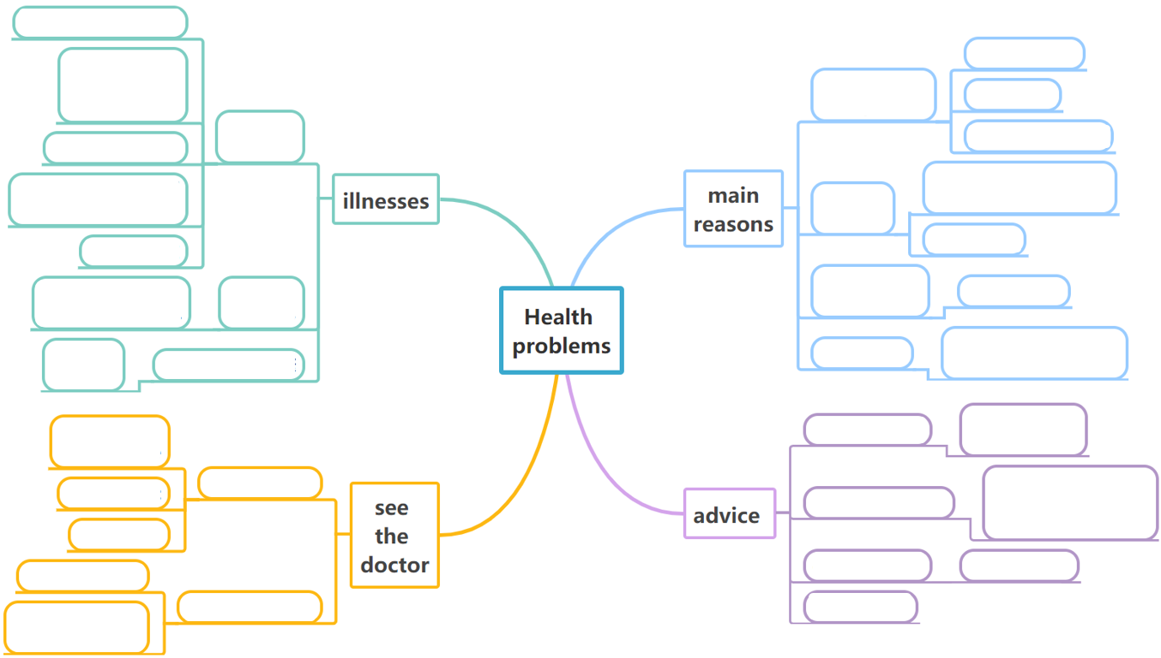

**任务2：Read and finish their problems and try to give some advice.**

|  |  |  |
| --- | --- | --- |
| **People** | **Problems** | **Advice** |
| 1612048812(1)_副本1 | I like burgers, chips and cola very much. I can't stop once I start eating or drinking. Recently I feel worried because I \_\_\_\_\_\_\_\_\_ (be) putting on much weight for a month. |  |
| 1612087592(1)_副本 | I used to be very fat. In order to be thin, I \_\_\_\_\_\_\_\_\_ (not have) breakfast or dinner since July, 2020. Till now, I \_\_\_\_\_\_\_\_ (lose) a lot of weight. But I often feel tired and don't want to eat anything. |  |
| 1612044747(1)_副本 | I love playing computer games with my friends. I also watch TV and eat fast food. I know it's not healthy but I don't know how to stop and become healthier. |  |
| 1612054319(1)_副本 | I'm quite busy this year. I \_\_\_\_\_\_\_\_\_\_\_ (work) with computer from morning till night since January. My shoulder hurts a lot and I can hardly lift my right arm. |  |
| 脱发_副本 | I always work late till midnight. My hair \_\_\_\_\_\_\_\_\_ (keep) falling off a lot for nearly two months. It's terrible! |  |

**任务3：Writing task**

每年的4月7日是世界卫生日World Health Day，为了呼吁全世界的青少年做好卫生保健，青少年卫生组织决定举办以Keeping healthy为主题的英文演讲比赛。请你写一篇文章参加初赛，谈谈保持健康的重要性、你平时做哪些锻炼以及给大家一些保持健康的建议。

提示词语：important, running, habit, food, exercise, sleep

提示问题：• What do you think of keeping healthy?

• What exercise do you usually take?

• What do you advise people to do?

|  |
| --- |
| Structure |

**Keeping healthy**

\_\_\_\_\_\_\_\_\_\_\_\_\_\_\_\_\_\_\_\_\_\_\_\_\_\_\_\_\_\_\_\_\_\_\_\_\_\_\_\_\_\_\_\_\_\_\_\_\_\_\_\_\_\_\_\_\_\_\_\_\_\_\_\_\_\_\_\_\_\_\_\_\_\_\_\_\_\_\_\_\_\_\_\_\_\_\_\_\_\_\_

\_\_\_\_\_\_\_\_\_\_\_\_\_\_\_\_\_\_\_\_\_\_\_\_\_\_\_\_\_\_\_\_\_\_\_\_\_\_\_\_\_\_\_\_\_\_\_\_\_\_\_\_\_\_\_\_\_\_\_\_\_\_\_\_\_\_\_\_\_\_\_\_\_\_\_\_\_\_\_\_\_\_\_\_\_\_\_\_\_\_\_

\_\_\_\_\_\_\_\_\_\_\_\_\_\_\_\_\_\_\_\_\_\_\_\_\_\_\_\_\_\_\_\_\_\_\_\_\_\_\_\_\_\_\_\_\_\_\_\_\_\_\_\_\_\_\_\_\_\_\_\_\_\_\_\_\_\_\_\_\_\_\_\_\_\_\_\_\_\_\_\_\_\_\_\_\_\_\_\_\_\_\_

\_\_\_\_\_\_\_\_\_\_\_\_\_\_\_\_\_\_\_\_\_\_\_\_\_\_\_\_\_\_\_\_\_\_\_\_\_\_\_\_\_\_\_\_\_\_\_\_\_\_\_\_\_\_\_\_\_\_\_\_\_\_\_\_\_\_\_\_\_\_\_\_\_\_\_\_\_\_\_\_\_\_\_\_\_\_\_\_\_\_\_

\_\_\_\_\_\_\_\_\_\_\_\_\_\_\_\_\_\_\_\_\_\_\_\_\_\_\_\_\_\_\_\_\_\_\_\_\_\_\_\_\_\_\_\_\_\_\_\_\_\_\_\_\_\_\_\_\_\_\_\_\_\_\_\_\_\_\_\_\_\_\_\_\_\_\_\_\_\_\_\_\_\_\_\_\_\_\_\_\_\_\_

\_\_\_\_\_\_\_\_\_\_\_\_\_\_\_\_\_\_\_\_\_\_\_\_\_\_\_\_\_\_\_\_\_\_\_\_\_\_\_\_\_\_\_\_\_\_\_\_\_\_\_\_\_\_\_\_\_\_\_\_\_\_\_\_\_\_\_\_\_\_\_\_\_\_\_\_\_\_\_\_\_\_\_\_\_\_\_\_\_\_\_

\_\_\_\_\_\_\_\_\_\_\_\_\_\_\_\_\_\_\_\_\_\_\_\_\_\_\_\_\_\_\_\_\_\_\_\_\_\_\_\_\_\_\_\_\_\_\_\_\_\_\_\_\_\_\_\_\_\_\_\_\_\_\_\_\_\_\_\_\_\_\_\_\_\_\_\_\_\_\_\_\_\_\_\_\_\_\_\_\_\_\_