**八年级（下）英语第4周第2课时**

**Module 4 Unit 2 学习指南**

**【学习目标】**

1. 能够通过归纳、总结healthy living主题下有关health problems及造成这些问题的原因的词汇，形成系统的词群意识，更好地掌握这个主题的词汇；
2. 能够通过梳理有关periLC neurons (神经元)的文章结构理解科学报告的文体特点；并通过阅读及分析语言，理解这项研究的结果以及研究意义；
3. 能够向他人转述科研报告的部分简要内容，并迁移创新，为他人提出有关该方面问题的建议。

**【学习任务】**

**任务1：Finish the mind map.**

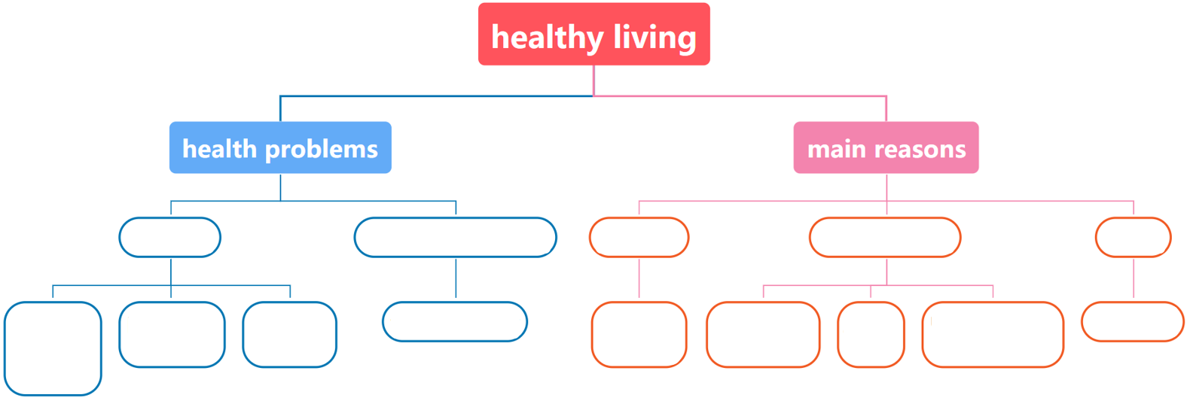

**任务2：Read and sum up the structure of this passage.**

**Why we love snacking**

It’s quite common for us to eat too much junk food. Just putting onetastysnack in your mouth makes you want more. And now, scientists have figured out (发现) why we do this.

A research team from the US looked at the brains of mice to see how their brains control their eating behavior (行为). They found a set of special *neurons* (神经元) and named them “periLC neurons”.

These neurons *affect* (影响) whether or not the mice will continue eating after having a snack. The neurons *fired* (传递信号) less than usual while the mice were eating or drinking. If the neurons were stopped from firing at all, the mice would eat even more. This creates a **cycle** - the mice eat and drink, the neurons fire less, the mice then feel like eating and drinking even more, and so it continues.

Of course, there are other neurons that make us feel full and stop eating. But this finding can help scientists begin to answer why it’s so easy to overeat. And by further studying these neurons, they may also find new ways to solve problems such as obesity (肥胖) and diabetes (糖尿病).

|  |
| --- |
|  |

**任务3：Read and choose the correct answers.**

( ) 1. The word “**cycle**” in Paragraph 3 probably means ______.

A. a short period of time B. something that happens over and over again

C. a bad influence D. continuous development

( ) 2. What is the passage mainly about?【多选题】

A. Why people like to eat junk food.

B. How we can stop eating too much.

C. Why we can’t stop snacking once we start.

D. How mice brains work differently from human brains.

E. How neurons affect eating behavior according to the study.

( ) 3. What can we learn from the last paragraph?

A. PeriLC neuron can make people feel full.

B. The findings might help solve health problems.

C. Overeating doesn’t cause obesity and diabetes.

D. The research might help people control their neurons.

**任务4：Task**

假如你叫李华，是国际青少年健康生活科研项目组的成员。项目组的英国朋友Tina给你发来邮件，谈到她最近的一些困扰。她喜欢吃快餐和零食，而且吃起来就无法让自己停下来，她十分担心自己的健康状况。请你根据刚才阅读的有关periLC neurons (神经元) 的研究报告，给她写一封回信，向她说明这个现象的原因，并给她提一些健康生活的建议。

提示词语：common, snack, brain, affect (影响), eating behavior (行为), stop, healthy, food, exercise

提示问题：• Why can't people stop once they start eating?

• What do you advise her to do?

|  |
| --- |
| *Dear Tina,*  *Don't worry so much about yourself.* ________________________________________________________  ______________________________________________________________________________________________________________________________________________________________________________________  ___________________________________________________________________________________________  ___________________________________________________________________________________________  ___________________________________________________________________________________________  ___________________________________________________________________________________________  ___________________________________________________________________________________________  ___________________________________________________________________________________________  *Yours,*  *Li Hua* |