**八年级（下）英语第2周第3课时**

**Module 2 Unit 3 学习指南**

**【学习目标】**

1. 掌握现在完成时的结构并能在合适的语境下使用现在完成时；
2. 能够熟练运用常见不规则动词的过去分词形式；
3. 能够正确使用have done及has done的结构表达或询问个人的经历。

**【学习任务】**

**任务1：** **Please write the past participle of the following words.**

* hurry --- walk --- stop---
* notice --- look --- marry---
* step --- decide--- plan ---

**任务2：Please tell the past participle of the following expressions.**

 eat: They have _eaten in a restaurant.

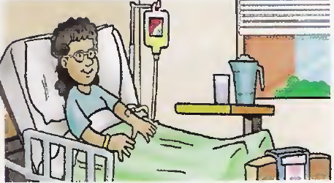 be: She has ______ in the hospital.

 see: She has ______ a movie.

 do: He has ______ some washing.

 give: She has _______ a speech.

 get: She has ______ a letter.

**任务3：Please choose from the box and use the correct form of the verb.**



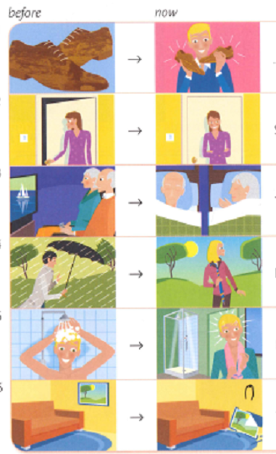

The __________________________

He __________________________

It __________________________

They ________________________

She _________________________

He has cleaned his shoes.

**任务4：Please write the negative form of the following sentences.**

1. We have travelled around the world.

2.You have been to England.

3.She has been to Beijing.

**任务5：Please write questions with Have/has… and answer them.**

Yes, I have.

Have you driven the new van?

 **_______________________________________________________________**

 

 