**八年级（下）英语第3周第4课时**

**Module 3 Revision学习指南**

**【学习目标】**

1. 能够通过阅读获取有关国内外太空探索的信息，并借助图片描述太空探索的重要事件;
2. 能够书面介绍中国太空探索已取得的成就以及嫦娥五号探测器的细节信息。

**【学习任务】**

**任务1：Read and answer.**

**Journey to space in some countries**

Yuri Gagarin was an astronaut from the former Soviet Union (前苏联) and became the first person to space on April 12,1961. The flight lasted only 108 minutes, but it opened up outer space to human exploration (探索).

The spacecraft Apollo 11 took astronauts to the moon for the first time. US astronaut Neil Armstrong was the first human to walk on the moon on July 20, 1969.

Oct 15, 2003 was a day to remember in the history of China because China launched (发射) its first manned spacecraft, Shenzhou V. Yang Liwei became China’s first astronaut who was sent into space. Tianwen-1, the first Mars probe (探测器) in China, was launched (发射) on July 23, 2020. This stood for the beginning of China’s Mars exploration program (探测计划). In addition, Chinese scientists are working hard and planning to send astronauts to the moon before the year 2030.

1. Have scientists already sent astronauts into space?_________________________________________________

2. Have astronauts already been to the moon?_______________________________________________________

3. Have Chinese scientists already sent manned (载人的) spaceships into space?

_________________________________________________________________________________________

4. Have Chinese scientists already sent a Mars probe (探测器)?

_________________________________________________________________________________________

5. Have Chinese scientists already sent astronauts to the moon?

_________________________________________________________________________________________

**任务2：Learn about Chang’e-5.**

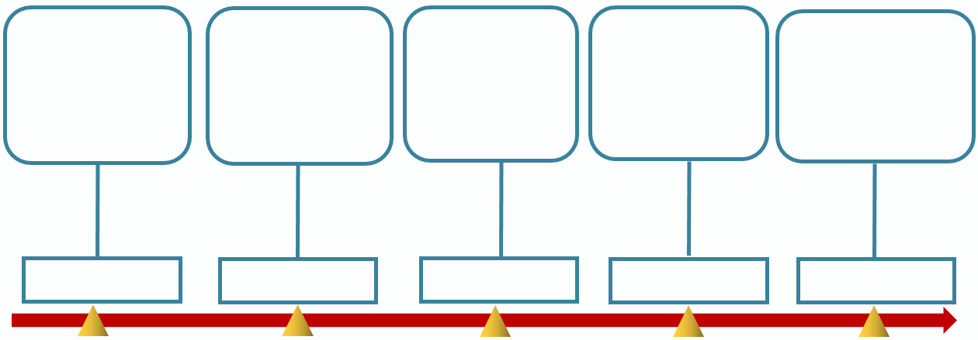

Carrier rocket was launched with Chang’e-5 probe.

2020.12.17

2020.12.6

2020.12.2

2020.12.1

2020.11.24

**任务3：Write an email to Mike.**

假如你是中学生李华，你的英国朋友Mike给你发了邮件，询问中国太空探索 (exploration) 已经取得的重要成就 (achievement) ，中国嫦娥五号任务 (mission) 执行的过程，以及你对嫦娥五号成功返航的看法。请你根据以下要点给Mike回封不少于50词的邮件。

1. What achievements has China made in space exploration?
2. What has Chang’e-5 done on the moon?
3. What do you think of Chang’e-5 mission?

Dear Mike,

I’m glad to hear from you. Today, let me tell you something about the achievements China has made in space exploration and Chang’e-5 probe. __________________________________________________

____________________________________________________________________________________________________________________________________________________________________________________________________________________________________________________________________________________________________________________________________________________________________________________________________________________________________________________________________________________________________________________________________________________________________________________________________________________________________________________________________________________________________________________________________________________________________________________

I hope this will help you know more about China’s space exploration.

Yours,

Li Hua