**八年级（下）英语第3周第1课时**

**Module 3 Unit 1学程拓展**

**一、请同学们听音频，阅读文章，了解宇航员太空旅行的经历。**

**Ask these astronauts**

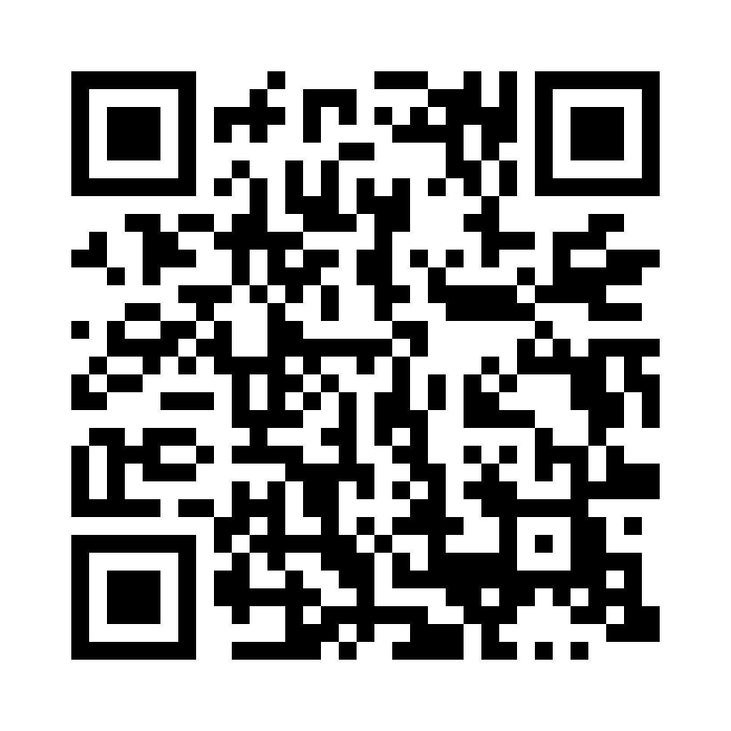Meet Christina Koch and Jessica Meir. They are two female (女性的) astronauts working for NASA. Koch and Meir made history on Oct 18, 2019, when they completed (完成) the first all-female spacewalk. Time magazine named the pair as some of its “100 Most Influential (有影响力的) People in the World” of 2020.

Nice to meet you! My name is Jessica Meir. I’m 43 years old. I’m a physiologist (生理学家). I’m from the United States.

**Have you always wanted to go into space?**

Ever since I was a child, I have always said that I wanted to be an astronaut. At age 13, I went to NASA summer camp. In my high school yearbook, I wrote “go for a spacewalk” on a list of my plans for the future. My next big dream is to walk on the moon.

**What does it feel like in space?**

Everything is more fun when you’re floating (漂浮) inside the space station. You can float up and down, or do some cartwheels (侧手翻) in midair, or fly around like Superman.

Nice to meet you! My name is Christina Koch. I’m 41 years old. I’m an engineer. I’m from the United States.

**Have you always wanted to go into space?**

I knew I wanted to be an astronaut at 5 years old. I worked hard to realize (实现) my dream. I went to space camp. I learned rock-climbing. I worked in Antarctica. All of these things have helped me become a better astronaut.

**How long did you stay in space?**

Actually, I was in space for quite a long time. From 2019 to 2020, I worked aboard (在……之上) the International Space Station for 328 days. It was the longest single (单人的) spaceflight by a woman. Yes, I set another record (纪录)!

**二、请同学们根据歌词和视频，学唱歌曲，进一步认识太阳系。**

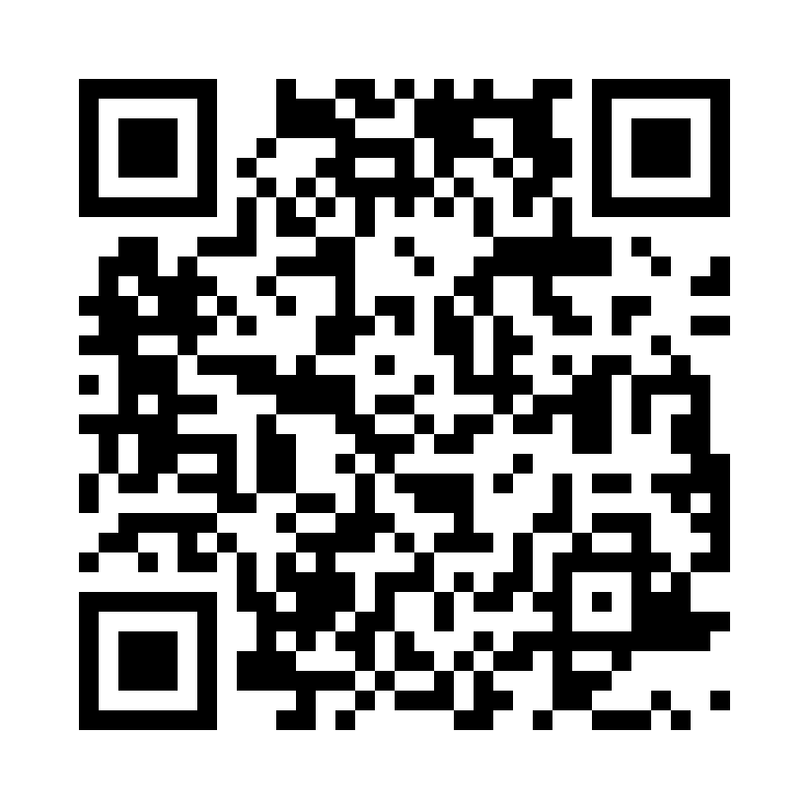I am the sun. I’m a burning ball of fire. I’m very big indeed. Life on earth depends on me. I am the sun.

I am Mercury. I’m the closest planet to the sun. I’m a ball of iron —I have no moons (卫星). I am Mercury.

I am Venus. I’m the same size as the Earth, but I spin the other way and much more slowly. I have no water —I am Venus.

I am the Earth the place where we all live. There is land and lots of sea so I look blue. I have a moon. I am the Earth.

I am Mars. I’m a rocky, red planet. My mountains are the highest in our solar system. I have 2 moons. I am Mars.

I am Jupiter. I’m a gas giant. I’m the biggest and I spin the fastest. I have the biggest moon. I am Jupiter.

I am Saturn. I’m a gas giant. My rings are made of ice. Titan is my biggest moon. I am Saturn.

I am Uranus. I’m an icy gas giant. I’m the coldest planet in our solar system. And I have rings made of dust. I am Uranus.

I am Neptune. I’m an icy gas giant. I’m the farthest planet from the sun. I have many storms. I am Neptune.

We are The Solar System.