**八年级（下）英语第3周第1课时**

**Module 3 Unit 1学习指南**

**【学习目标】**

1. 能够听懂关于太空探索的独白并准确获取细节信息。
2. 能够根据表格内容复述太空探索重要人物加加林的生平经历。

**【学习任务】**

**任务1：Listen and choose the right picture.**

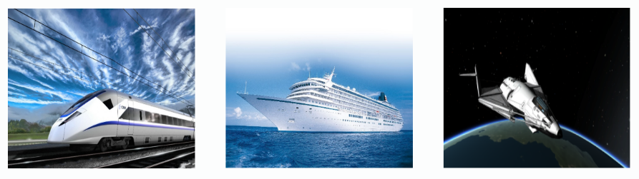**1.**

A B C



**2.**

A B C

 **3.**

A B C

 **4.**

A B C

**任务2：Listen and choose the best answer.**

1. How is the air for life on Mars?

A. It’s good. B. It isn’t good. C. There is no air on Mars.

2. Have scientists found any life on Mars yet?

A. Yes, they have. B. No, they haven’t. C. We don’t know.

3. What’s the speaker mainly talking about?

A. When people will go to Mars.

B. How people could go to Mars.

C. What people have known about Mars.

**任务3：Listen and fill in the blanks.**

|  |  |
| --- | --- |
| **The world’s first person to travel into space-Yuri Gagarin** | |
| When | What happened |
| On 9th 1._________1934 | was born |
| In 1949 | became a(n) 2.________ and studied at a local school at night |
| In 1955 | began to study in the First Chkalov Air Force pilot’s school |
| In March 1960 | became a(n) 3.___________ |
| On 12th April 1961 | started his journey to 4.__________ |
| On 27th March 1968 | died in the 5.__________ accident |

**任务4：Retell Yuri Gagarin’s life history.**