**八年级（下）英语第4周第3课时**

**Module 4 Unit 3 学习指南**

**【学习目标】**

1. 能够根据语境及时间提示词，在现在完成时的句子中准确判断和使用since和for。

2. 能够运用现在完成时及since和for描述自己和他人良好的生活习惯。

**【学习任务】**

**任务1: Finish the corresponding（相应的） sentences in the two columns（专栏）. 「Practice 1」**

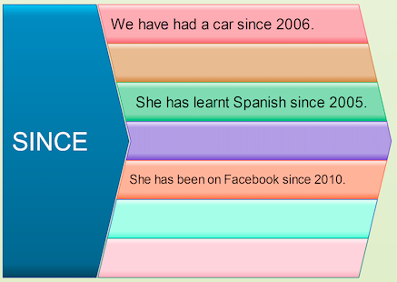

She has learnt Spanish since 2012.

She has been on Facebook since 2017.

I have been playing tennis since 2015.

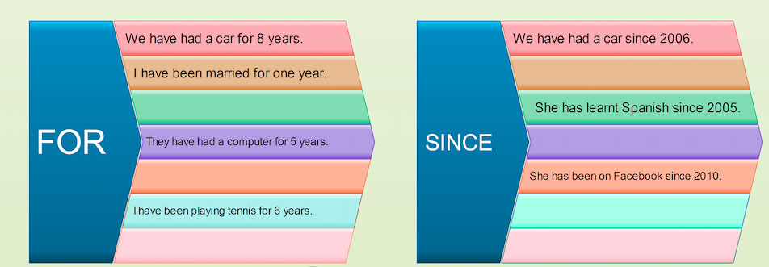

We have had a car for 8 years.

I have been married for one year.

They have had a computer for 5 years.

**任务2: Answer the questions. 「Practice 2」**

Example: How long have you studied German ? ( 2004)

I have studied German since 2004.

1. How long have you learnt English? (8 years)

_____________________________________________

2. How long have you been in this school? (2019)

_____________________________________________

3. How long have you lived in Paris? (a long time)

_____________________________________________

4. How long has Jim been on holiday? (Saturday)

_____________________________________________

5. How long has Helen known Paul? (2 months)

_____________________________________________

**任务3：Talk about your good habits with “since” or “for”.**

_____________________________________________

_____________________________________________