8年级（上）英语第66课时（第17周）
《阅读一点通之阅读细节》学习指南
【学习目标】
- 能够识别非虚构类文本和虚构类文本；
- 能够运用“从图片中得到更多信息；关注主题、副主题、细节”等阅读技能完成细节理解题、主旨大意题和推理判断题。
【学习任务】
任务1：填空
1.阅读A篇多为__________________文本。
2.阅读B篇多为__________________文本。
任务2：阅读下列短文，根据短文内容，从短文后各题所给的A、B、C、D四个选项中，选择最佳选项。
A
The traditional Chinese lunar calendar divides a year into 24 solar terms. In the ancient days, they were important instructions for the farming production as well as people’s daily lives. Here are four solar terms and some details about them.
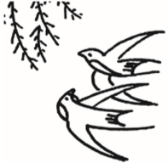 | Spring Equinox  It starts around March 21st. During this time, swallows fly back to the north. It is also a good time for people to fly kites and eat spring vegetables.
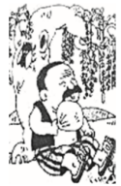 | Summer Solstice  It begins around June 21st. To celebrate Summer Solstice, people often give colored fans to each other because fans can help them cool down.
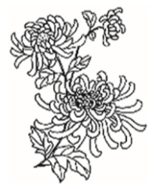 | Autumn Equinox  It starts around September 23rd. From Autumn Equinox, most of the areas in China will enter the cool autumn. It is a season for people to eat crabs and enjoy chrysanthemums (菊花).
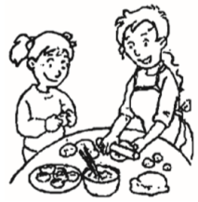 | Winter Solstice  It begins around December 22nd. It marks the arrival of the coldest season in the year. People usually make and eat dumplings with their family members.
21. Spring Equinox begins around__________.
A. March 21st B. June 21st C. September 23rd D. December 22nd
22. To celebrate Summer Solstice, people________.
A. eat spring vegetables B. give each other colored fans
C. enjoy chrysanthemums D. make and eat dumplings
23. _________marks the arrival of the coldest season in the year.
A. Spring Equinox B. Summer Solstice C. Autumn Equinox D. Winter Solstice

A B D

