**8年级（上）英语第69课时（第18周）**

**《我眼中的北京城》学习指南**

**【学习目标】**

1. 能够罗列出介绍一个城市需要涵盖的信息。
2. 能够使用不同的句型介绍城市的基本信息。
3. 能够通过添加主题句、相关细节信息、举例等方式丰富介绍城市的表达。

**【学习任务】**

**任务1：**

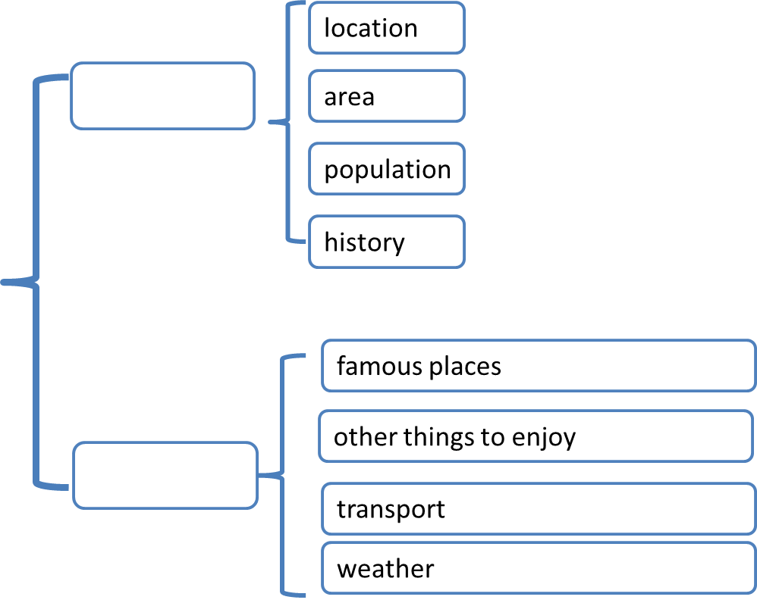

Beijing

**任务2：Basic information**

① Location:

* Beijing is the capital of China. It ___________the northeast of China.
* Beijing is the capital of China. It ___________the northeast of China.

② Area:

It _______________over 16 million square kilometres.

③ Population:

* Beijing __________________ about 21 million.
* _________________Beijing is about 21 million.
* Beijing is a large city _______________ about 21 million.

④ History:

* Beijing _________________ over 3000 years.
* Beijing is an old city _______________ over 3000 years.

***How to improve it?***

Beijing is the capital of China. It lies in the northeast of China. It covers an area of over 16 million square kilometres. Beijing has a population of about 21 million. It has a history of over 3000 years.

___________________________________________________________________________________________

___________________________________________________________________________________________

**任务3：Travel**

**① Famous places**

* **___________________tourist attractions in Beijing, __________ the Palace Museum, the Great Wall, the Summer Palace and the Temple of Heaven.**
* With such a long history, Beijing____________________some places of interest, such as the Palace Museum, the Great Wall, the Summer Palace and the Temple of Heaven.

② Other things to enjoy

* There are also some other things to do to___________ the Beijing culture. You can the _________the Beijing Opera, _________the cross talk show and ________Hutong.
* It’s also a must to ________ the Beijing Roast Duck and traditional Beijing snacks.

③ Weather

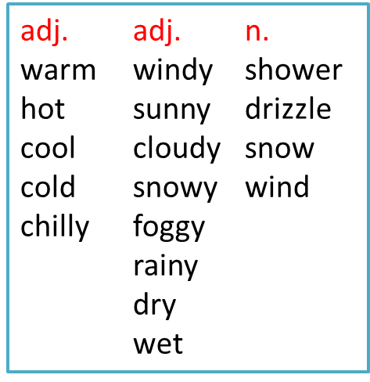In spring, it is _____________. Sometimes there are___________________

In summer, it is ________. There may be___________from time to time.

In autumn, it is _________ and comfortable.

In winter, it is ________. There is always heavy _______.

***How to improve it?***

In spring, it is warm. Sometimes there are strong winds and drizzle. In summer, it is hot. There are showers from time to time. In autumn, it is cool and comfortable. In winter, it is chilly. There is always heavy snow.

___________________________________________________________________________________________

___________________________________________________________________________________________

④ Transport

***How to improve it?***

We can travel around Beijing by bus, by subway, by taxi or by bike.

___________________________________________________________________________________________

___________________________________________________________________________________________

**任务4：Practice**

中国日报社发起了“向世界介绍首都北京”的征文活动，请你写一篇文章，介绍一下北京，帮助更多的人了解它。你的文章应该包括以下方面：北京的基本信息(如地理位置和人口)，北京的著名景点，其他推荐游客体验的活动，来北京旅行的最佳时间和最佳交通方式 。(不少于60词)

提示词：north, over 21million, the Palace Museum, Beijing Roast Duck, autumn, by subway

* Where is Beijing?
* What’s the population of Beijing?
* What are some famous places people can visit?
* What else people can do here?
* What’s the best time to visit Beijing?
* What’s the best way to travel in Beijing?