**8年级（上）英语第59课时（第15周）**

**《听说专项—记录并转述篇》学程拓展**

一 、听后选择（共8小题；每小题1.5分，共12分） 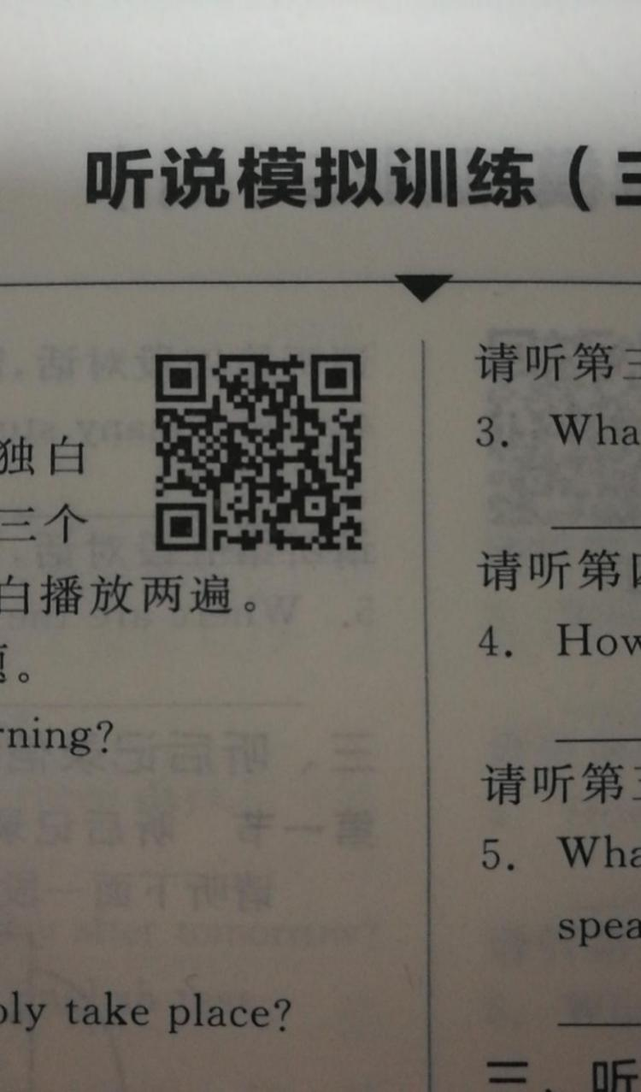

**（请扫二维码 收听作答）**

请听第一段对话，完成第1至第2小题。

1. What will Jack do on Saturday morning?

A. Visit the old people’s home. B. Have a singing lesson. C. Take his guitar lesson．

2. When does the conversation probably take place?

A. After school． B. During the break． C. In class.

请听第二段对话，完成第3至第4小题。

1. What does the man’s son look like?

A. Tall and thin. B. Short and thin. C. Short and fat.

4. How much will the man pay in total?

A. 150 yuan. B. 162 yuan. C. 165yuan.

请听第三段对话，完成第5至第6小题。

5. How often does the boy have the tennis lesson?

A. Once a week. B. Twice a week. C. Three times a week.

6. How long is each lesson?

A. 100 minutes B. 90 minutes. C. 80 minutes.

请听下面一段独白，完成第7至第8小题。

7. What can we know from the speech?

A. Diana is a doctor now.

B. Diana is the speaker’s sister.

C. Diana came to the speaker’s fourth birthday party.

8. What does the speaker think of Diana?

A. She doesn’t care about others.

B. She is tired of studying.

C. She sets a good example.

二、听后回答（共5小题；每小题2分，共10分）

请听第一段对话，回答第1小题。

1.What did Linda use to be like?

请听第二段对话，回答第2小题。

2. What does Paul enjoy drinking?

请听第三段对话，回答第3小题。

3. What is the man doing?

请听第四段对话，回答第4小题。

4. How did Steven get to the countryside from school?

请听第五段对话，回答第5小题。

5. What’s the probable relationship between the two speakers?

三、听后记录信息并转述（共两节；每节5分，共10分）

第一节 听后记录信息（共5小题；每小题1分，共5分）

|  |  |
| --- | --- |
| Information about the Tour Plan | |
| This island and the weather | * a beautiful and quiet island where they can relax, sit by the beach, enjoy great 1__________ and feel very safe * a bit 2___________ in the coming days |
| Plan for today | * go 3__________ in the rainforest * a bit tiring but exciting |
| Plan for tomorrow | * take a bus around the island * visit a fruit farm in the morning and some lovely quiet 4__________ in the afternoon * If someone wants to do some shopping in the central town, he can take the local 5__________. |

下面请在90秒内将所缺信息输入到指定的答题区域。

请在以下区域作答

1．______ 2.________ 3.________ 4._________ 5._________

第二节听后转述信息（共5分）

请再听一遍短文，完成转述。请将你所听到的内容转述给没有听到的同学。你的转述可以这样开始：***Gina tells us some information about the Tour Plan...***

四、朗读短文(共8分)

朗读短文。现在，你有1分钟的时间浏览短文并做录音准备。

There are four keys to English study: listening, speaking, reading and writing. Firstly, we should be brave enough to talk with others in English. By doing this, we can improve our talking and listening skills. Secondly, we should often read English books. When we see a new word, we should guess its meaning first, and then look it up in the dictionary to have a check. Thirdly, we should often practise our writing skills. As long as we listen, speak, read and write more, we are sure to make progress!

**《听说专项—记录并转述篇》学程拓展参考答案**

一、听后选择1.C 2. B 3. C 4 B 5.A 6. C 7.A 8. C

二、听后回答

1. She/Linda used to be shy.

2. Tea.

The boy/ He likes drinking tea.

1. The man is asking the way to the library.
2. By bus.
3. They are classmates.

三、听后记录&转述（共两节；每节5分，共10分）

听后记录信息（共5小题；每小题1分，共5分）

1. meals 2. rainy 3. walking 4. villages 5. bus

听后转述参考答案:

*Gina tells us some information about the Tour Plan.* We are going to visit a beautiful and quiet island where we can relax, sit by the beach, enjoy great meals and feel very safe. The weather will be a bit rainy in the coming days, so it’s a good idea to take an umbrella. Today we are going walking in the rainforest. It will be a bit tiring but exciting. Tomorrow we are going to take a bus around the island. We are going to visit a fruit farm in the morning and some lovely quiet villages in the afternoon. If someone wants to do some shopping in the central town, he can take the local bus.

四、朗读短文(共8分)

