**8年级（上）英语第50课时（第13周）**

**《抗震应急你最棒》学习指南**

**【学习目标】**

1. 获取并梳理地震自救的有效方法，并根据各级标题获取文章大意；
2. 通过梳理抗震准则，复述文章；
3. 以文章结构为支撑，帮助班长Tom设计班级抗震演练海报；
4. 建立抗震知识体系，形成乐于助人的意识。

**【学习任务单】**

**任务一：Do you know what happened on May 12th, 2008? How many people died or were missing?**

**___________________________________________________________________.**

**任务二：Brainstorm ideas about what to do during an earthquake.**

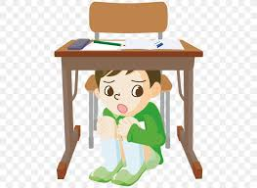

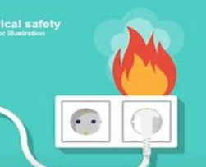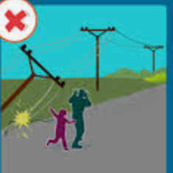 _________________ _______________ _______________



**_____________ _____________**

**任务三：Read and match the pictures on PPT with the paragraphs.**

If indoors,

1. Try to stay calm, stay put. Don't panic or lose your cool.
2. Drop to the ground on your hands and knees, take cover by

getting under a sturdy table or other piece of furniture, and hold

on until the shaking stops.

1. If there isn't a table or desk near you, cover your head with

your arms and crouch in an inside corner of the building.

1. Stay away from glass, windows, walls, and anything that could

fall, such as lighting fixtures or furniture.

1. Be careful that the electricity may go out or the fire alarms may

turn on. Don't touch anything with electricity.

1. Do not use the lifts. A lift runs using electricity power and you

could get stuck helplessly.

If outdoors,

1.Keep clear of buildings, trees, signs, power lines and street lights.

Once in the open area, stay there until the shaking stops.

2.If you are in a car or bus, make sure the driver pull over to the side

of the road. Stay inside until the shaking is over.

3.Always check out what may fall. The greatest danger exists directly

outside buildings, at collapsing walls, flying glass and falling objects.

4.Be helpful and careful. Give a hand and stay safe.

**任务四: Read again and write down the letters of these pictures in the correct columns.**

|  |  |  |
| --- | --- | --- |
|  | Dos | Don’ts |
| 'Inside' Part |  |  |
| 'Outside' Part |  |  |

**任务五: Retell the passage with the help of this table in task four.**

It's difficult to warn people about earthquakes but we can try to stay safe

during an earthquake.

If we are inside, duck down _____________________________________.

Also, cover____________________________________________________ .

Besides, stay___________________________________________________.

Don't panic_______________________.

____________________electricity.

____________________lifts.

If we are outside, _____________________________________________.

Also, if you are in a car, make sure _________________________________. What’s more, always check________________________________________.

______________________________________________________________.

**任务六：The earthquake drill of this year will fall on Oct. 23rd. Could you help Tom make a poster for it to tell the class what to do in an earthquake.**

1. An eye-catching title.
2. Dos and don’ts.(Summarize what we have learnt today and search for more online)
3. Attractive photos.