**8年级（上）英语第49课时（第13周）**

**《安全急救一起学》学习指南**

**【学习目标】**

1. 能够听懂关于急救内容的对话，并通过抓住关键词，获取对话大意和相关细节信息；
2. 梳理应对不同生活中意外伤害的不同急救方法；
3. 以网络咨询者和在线医生的身份谈论如何对出现意外伤害的朋友实施急救。
4. 建立救援知识体系，形成乐于助人的意识。。

**【学习任务单】**

**任务一：Brainstorm and vocabulary.**

**What are the common injuries（受伤）or illness in daily life?**

**________________________ ________________________**

**________________________ ________________________**

**________________________ _________________________**

**任务二：Listen and number the pictures in order you hear them. Optional: write down the names of these accidents.**

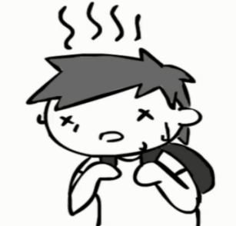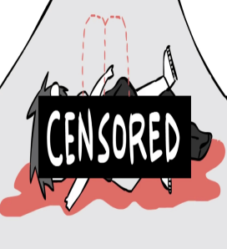

___________________ __________________ __________________

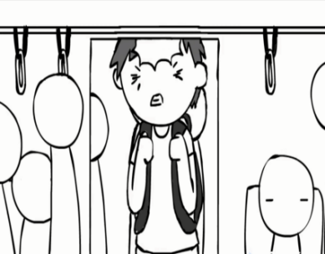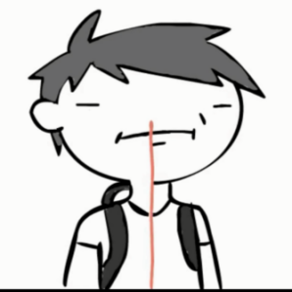

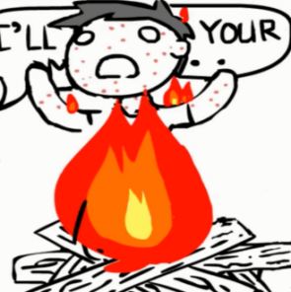 **_______________ _______________ ________________**

任**务三：How to practise first aid? Listen again and complete the table.**

|  |  |
| --- | --- |
| **injuries&**  **illness** | **first aid** |
| 1. head injury | Apply a cold compress, such as an or frozen vegetables. |
| 2. nose bleeding | Pinch the of the nose, (just below the bony ridge);  lean and breath through |
| 3. heat stroke | Apply , cloths or towels;  drink cool water . |
| 4. choking | Hit them firmly on their between the shoulder blades for times. |
| 5. burn | Cool the burn under , water for at least 10 minutes. |
| 6. bleeding | Put pressure on the wound to stop or slow down the . |

**任务四: Talk to your partners on WeChat, ask and answer how to give first aid to some common injuries in life. Screen cut your chats.**

***A: You are with your friends in the pictures below. “My friend Tony is burnt, what should I do?***

***B: You are a doctor giving medical advice online“ Cool......”***

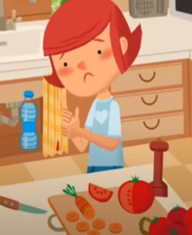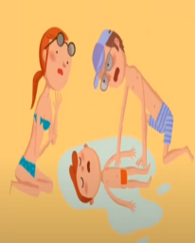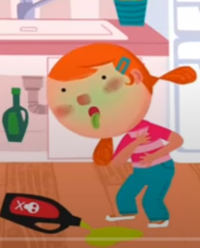Tony Lucy Claire Tom

is burnt has got food poisoning gets cut is drowning