**8年级（上）英语第44课时（第11周）**

**《最佳旅游季》学习指南**

**【学习目标】**

能够有条理地思考并给予外国笔友来中国旅游的建议

**【学习任务】**

**任务1：看图根据表格提示信息补全句子。**

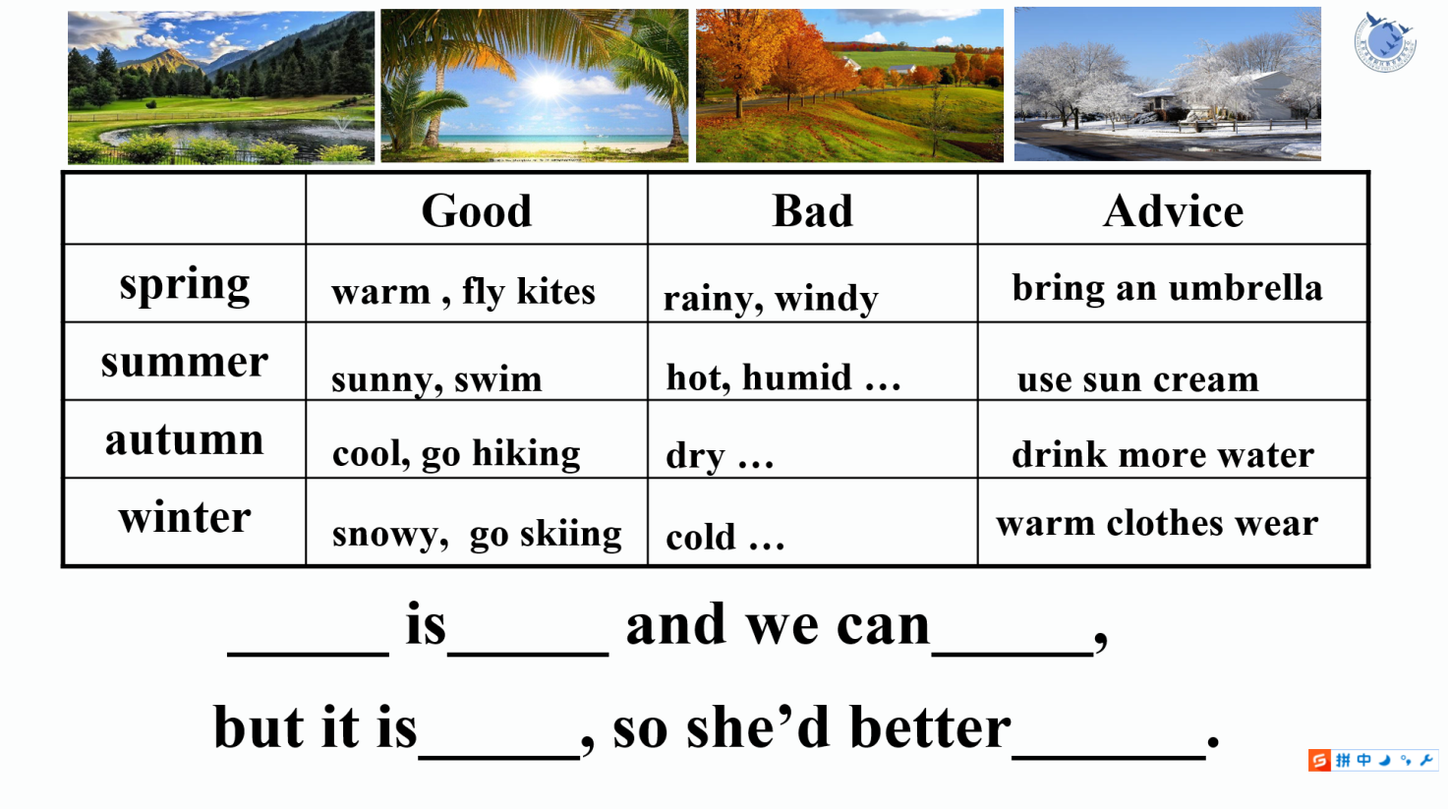

1. It is_____ in _____ and we can , but it is_____, so she’d better .
2. It is_____ in _____ and we can , but it is_____, so she’d better .
3. It is_____ in _____ and we can , but it is_____, so she’d better .
4. It is_____ in _____ and we can , but it is_____, so she’d better .

**任务2：给网友写一封回信，介绍来中国旅游的最佳季节并提出建议。**

