**8年级（上）英语第42课时（第11周）**

**《Weather on Mars》学习指南**

**【学习目标】**

1. 能够观看短视频，并把地区和相应天气进行匹配；
2. 能够读懂有关火星的阅读材料，获取相关信息。

**【学习任务】**

**任务1：**

Watch the video and match the places with the weather there.

|  |  |
| --- | --- |
| 1. **Canada** 2. **Mexico** 3. **England** 4. **France** 5. **Russia** 6. **Australia** 7. **Japan** 8. **Mars** | 1. **cold** 2. **cloudy** 3. **foggy** 4. **hot** 5. **snowy** 6. **rainy** 7. **sunny** 8. **No ide**a. |

**任务2：**

Read the passage quickly and find the answers to the questions below:

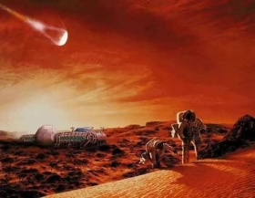 Meet our Space Neighbor – Mars

The ground is red, and the sky is pink. What a colourful world! Come to Mars and see the beautiful view!

Mars is the fourth planet from the sun. (Earth is the third one from the sun.) Its name comes from the Roman god of war(罗马战神). People also call Mars the “red planet”, because there is red dust on Mars. When it is windy, the sky is almost red.

A day on Mars is a little more than 24 hours, nearly the same length as an Earth day, but a year on Mars is about 687 days, that is almost as long as two Earth years. So if we live on Mars, how old are you now?

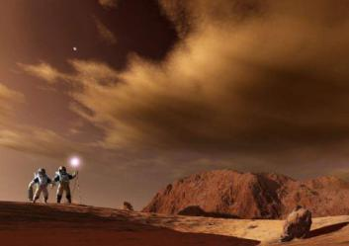 Mars is the nearest planet to Earth. The temperature (温度) there goes from -15℃ to 5℃. The average surface temperature (表面平均温度) on Mars is -62 ℃. When the sun sets, it can be terribly cold, as low as -176 ℃. So if you want to visit Mars, don’t forget to bring your spacesuit (宇航服). It can keep you warm. A NASA (美国国家航空航天局) team tested a Mars spacesuit. It costs $100,000. It can stand very cold weather and very strong wind.

People began to learn about Mars in 1960. America sent many probes(探测器) there. In 2008, the American Mars probe found something like ice on Mars. This means there might be water there. We have sent our Mars probe, Tianwen-1, on July 20, 2020. It will reach Mars in 7 months. It will study the space environment of Mars. Five more countries and regions also sent probes to Mars.

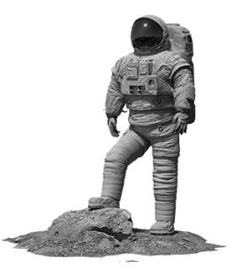There are two moons to Mars – Phobos and Deimos. But they are much smaller than the moon to Earth. Unlike other moons, Mars’ moons are asteroids (小行星) that were captured (捕获) by the planet’s gravity (重力)and will crash (撞击) into it in the future.

The Red Planet’s gravity is only 37 percent of the Earth’s. So you would jump nearly three times higher on Mars. And also because of this, you weigh only 1/3 on Mars than that on Earth.

1. The average temperature on Mars is _________.

A. -35 ℃ B. 5℃ C.-62℃

2. The sky on Mars is _____.

A. blue. B. red. C. pink.

3. What is the nickname(外号) of Mars?

A. The Hot planet. B. The Pink Planet. C. The Red Planet.

4. A year on Mars equals(相当于) almost _____ years on Earth.

A. two. B. five. C. ten.

5. Mars has _____ moon(s).

A. one. B. two. C. three

6. A man on Mars is ______ that on Earth.

A. as heavy as B. much lighter than C. more heavier than

**任务3：**

Try to answer the following questions:

1. Which planet is nearer to the sun, the earth or Mars?
2. How old are you if we live on Mars?
3. How many countries sent their probes(探测器) to Mars?
4. How tall can you jump on Mars?
5. Will there be moons to Mars in the future?

**任务4：**

Mars is so cold! Now you have a chance to go to Mars, what clothes will you take with you? If you can only bring ONE of your favourite things, what would you like to bring? And why?