**8年级（上）英语第45课时（第 12 周）**

**《趣谈送礼的学问》学习指南**

**【学习目标】**

1. 能够掌握礼物相关词汇；
2. 能够从听力中获取送礼物的具体信息；
3. 能够用情态动词谈论在中国送礼物的禁忌。

**【学习任务】**

**任务1：Words study**

Try to match the words and the pictures.

baseball cap chess set chocolate chopsticks dictionary toy video game books



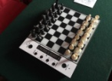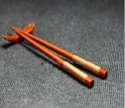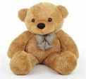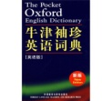

**任务2：Video learning**

Watch the video and answer the questions.

1. When did the man give gifts to his Chinese girlfriend?
2. Why did the man give gifts to his Chinese girlfriend?
3. What gifts did the man give to his Chinese girlfriend?
4. Was the woman happy? Why?

**任务3：The taboos ( 禁忌 ) of gift giving in China**

Tick out　(√)　the gifts that are not welcomed in China.

umbrella shoes clock towel chrysanthemums anything in black and white

pears scissors and knife the gifts showing number four

**任务4：Summary**

Write down the Chinese meaning of the following modal verbs.

|  |  |  |  |  |  |  |  |
| --- | --- | --- | --- | --- | --- | --- | --- |
| should |  | can |  | must |  | had better |  |
| shouldn’t |  | can’t |  | mustn’t |  | had better not |  |

**任务5：Task**

If your English friend Tom wants to give his Chinese friend Daming a gift, please tell him some customs about gift giving in China. Try to help him not to make mistakes.

e.g. You can’t give him knives or scissors.

You’d better not give him a pair of shoes.

You mustn’t give him a clock!

Please write down your answers.