**8年级（上）英语第53课时（第14周）**

**《词汇训练“赢”》学习指南**

**【学习目标】**

1. 能够在上下文语境中正确理解单词的含义。
2. 在话题语境下灵活运用词汇。

**【学习任务】**

**任务1：Complete the sentences with the words in the box.**

**place radio improve advise mistakes**

**Advice for Betty on learning Chinese**

1. How about listening to the _________or reading a Chinese newspaper?
2. Watching Chinese films can __________ her Chinese.
3. It’s a good idea to write some words a day on paper and ________ them in her room.

Read them and try to use them.

1. I ____________ her to talk with her friends in Chinese.
2. Why not write down her __________ and the correct answers in notebooks?

**任务2：Complete the sentences with the correct form of the words in the box.**

**mean accept break clean taste month immediately shake hands**

**Traditions in China**

People ____________ a gift with both hands.

People shouldn’t open a gift ____________________.They open it later.

People mustn’t do any _______________ on the first day of the Spring Festival.

People mustn’t ____________ anything on the first day of the Spring Festival. It’s bad luck.

People had better not have their hair cut during the Spring Festival _________.

People must only use red paper for *hongbao* because red ___________ luck.

In the north of China, people eat lots of *jiaozi*. They ________ great.

People often ______________ when they meet someone for the first time.

**任务3：Complete the table.**

|  |  |  |  |
| --- | --- | --- | --- |
|  | **形容词** | **名词** | **动词** |
|  |  |  |  |
|  |  |  |  |
|  |  |  |  |
|  |  |  |  |
|  |  |  |  |
|  |  |  |  |
|  |  |  |  |

**任务4：Underline the correct words.**

The weather is not very good anywhere today. In the north, the temperature will be very low and it will snow. It will stay (1) snow / snowy for the next few days. In the west, there will be a few (2) storms / ice. It will (3) rainy / rain for two more days, then the sun will come out on Saturday. It will be (4) hot / snow in the south but (5) rainy / showers will arrive in the afternoon.

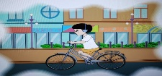**任务5：Describe what happened with the help of the pictures and the given words.**

**ride, listen to music**

A boy ____________ his bike and __________________ on the road.

**change**

The lights _________________ to red.

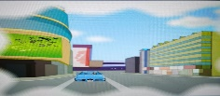**appear, corner**

A car suddenly _______________ round the ___________.

**talk**

The driver ___________________ on his mobile phone while he was driving.

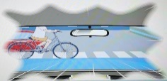**stop, in time**

The car ______________ just _______________.

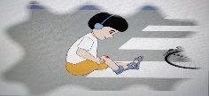**fall off, hurt**

The boy ______________ his bike and _______________ his knee.

**任务6：你的英国笔友Jack和家人对中国传统文化非常感兴趣。今年寒假他们将来北京学习中国传统文化。请你从汉语学习、中国的习俗、北京冬天的天气和交通安全四个方面给他们提些建议。**

**Advice to Jack and his family**

When you’re learning Chinese,______________________________________________________.

When you stay in Beijing, _________________________________________________________.

_____________________________________________ on the evening before the Spring Festival.

When you’re on the road,_________________________________________________________.