**8年级（上）英语第38课时（第13周）**

**《昔日乡镇换新颜》学习指南**

【学习目标】

1. 能够通过阅读，获取Linda和祖父眼中小镇今昔对比变化的信息
2. 能够利用获取的信息和语言，推理、判断祖父对于小镇变化的态度，并运用本课所学，谈论自己对于家乡变化的观点。

【学习任务】

任务1：Fast reading

1. Who are talking? And what are they talking about?
2. Complete the dialogue with the correct sentences.
3. They aren’t very expensive now. b) What was the traffic like before?

c) Were they all your old neighbours? d) Was my mum always at the shopping centre?

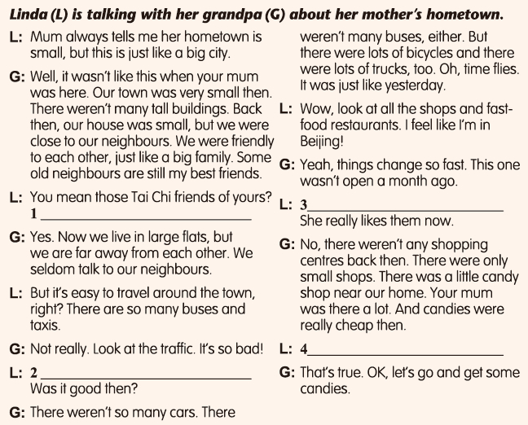

任务2：Careful reading

1. Has the town changed a lot?
2. What changes are mentioned in the dialogue?
3. Complete the chart.

|  |  |  |
| --- | --- | --- |
| changes in our town | sizes | then |
| now |
| houses | then |
| now |
| neighbours | then |
| now |
| traffic | then |
| now |
| shops | then |
| now |

任务3：Careful reading

1. Has everything changed in the town?
2. Does Grandpa like the changes?

任务4：Thinking

(1) Linda’s grandpa thinks the traffic is bad. What do you think causes the problem? And how can we solve the problem?

(2) What are the changes in your town? Do you like them?