**8年级（上）英语第39课时（第10周）**

**《330秘诀》学程拓展**

# The Uses of Numbers in Our Daily Life

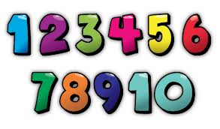

Numbers play an important role in our lives. Almost all the things we do involve numbers and Mathematics. Whether we like it or not, our life revolves in numbers since the day we were born. There are numerous numbers directly or indirectly connected to our lives.

          The following are some uses of numbers in our daily life:

 1. Calling a member of a family or a friend using mobile phone.

2. Calculating your daily budget for your food, transportation, and other expenses.

3. Cooking, or anything that involves the idea of proportion and percentage.

4. Weighing fruits, vegetables, meat, chicken, and others in the market.

5. Using elevators to go to places or floors in the building.

6. Looking at the price of discounted items in a shopping mall.

7. Looking for the number of people who liked your post on the Facebook.

8. Switching the channels of your favorite TV shows.

9. Telling time you spent on work or school.

10. Computing the interest you gained on your business.

**About the author:**Helen Raymundo

 Sources:https://www.ourhappyschool.com/mathematics/uses-numbers-our-daily-life