8年级（上）英语第36课时（第9周）
《英语新闻我来报》学程拓展
(一) 新闻拓展阅读
Passenger train derailed in northeast Scotland

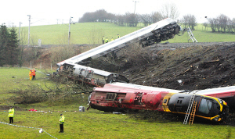
Three people died and six taken to hospital following the derailment of a passenger train near Stonehaven in Aberdeenshire, Scotland.
Pictures posted on social media showed smoke billowing behind trees from the area and a number of ambulances and emergency services at the scene.
British Transport Police said officers were called to the scene at 9:43 am and remain there alongside paramedics and the fire brigade.
Scotland's First Minister Nicola Sturgeon described the incident as "extremely serious".
"I've had an initial report from Network Rail and the emergency services and am being kept updated. All my thoughts are with those involved," Sturgeon wrote on social media.
The incident took place amid severe flooding across Aberdeenshire caused by torrential rain and thunderstorms.
Mick Lynch, senior assistant general secretary at transport trade union RMT, said, "Our priority at this time is to support our members, their colleagues and their families and to do all that we can to assist the rescue operation which RMT members are currently involved in."
"The facts behind this incident will need to be established in due course but at this stage we are focused on support and assistance and our thoughts are with all those impacted by this tragedy."

(二) 新闻网站公众号推荐.
1. 英文阅读网: www.enread.com
2. 英国新闻网: https://www.mirror.co.uk
3. 关注可可英语公众号, 在“听说读”专栏选择自己喜欢的频道, 寻找新闻资源，一起来学习吧！

