**8年级（上）英语第32课时（第8周）**

**《我给大家讲故事》学习指南**

**【学习目标】**

1. 能够借助图片和关键词复述所学故事。
2. 了解讲故事的程序和尝试操练讲故事。

**【学习任务】**

**任务1:**借助图片和关键词复述故事。

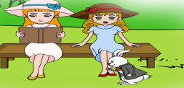 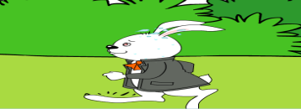

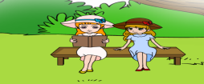

one day, sit, read suddenly, run by hear,watch

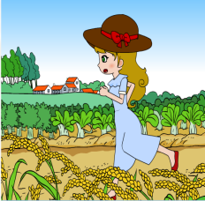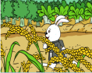

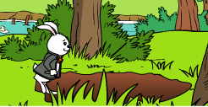  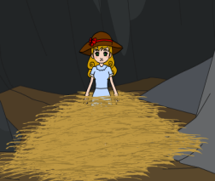

run across,after go down fall down finally, land

**任务2:**朗读下列句子，运用方框的词把以下句子写成一个文段。

A. She became very small.

B. Alice found a small key on a table.

C. She found a bottle with the words “DRINK ME”on it.

D. She opened a small door with the key and saw a beautiful garden.

|  |
| --- |
| after then next when at this time at last finally |

_____ she found a small key on a table. She opened a small door with it and saw a beautiful

garden. But she was too big to go through the door. ______, she found a bottle with the word“DRINK ME” on it. ______ she drank from the bottle and became very small.

**任务3:**听故事，填空并记录笔记。

Para.1

1. One day, I was with my friends. We were having a ______in a field and I saw

something strange.

1. There was a _____cat with a pink nose sitting in a tree.
2. It looked like it was eating the ______in the tree.

Notes:__________________________________________________________

Para.2

1. While I was looking at it, the cat got out of the tree, jumped down to the______, and

walked across the _____ and sat next to us.

1. The cat got up and ______close to me.
2. I ______to it and it smiled at me.

Notes:___________________________________________________________

Para.3

1. I found some biscuits in my ______ and gave them to the cat.
2. Soon, it was eating biscuits and ________at us.

Notes:___________________________________________________________

**任务4:** 复述故事。

One day, I ... with my friends. We...a picnic in a field and I saw something strange. There... a white cat with a pink nose sitting in a tree. There’s nothing strange about that, of course, but it ... like it ...the leaves in the tree! That ... strange! Cats don’t usually eat leaves. “Maybe it’s very hungry,” I thought.

While I ...at it, the cat got out of the tree, ... down to the ground and... across the field and... next to us. Maybe it wanted some of our picnic to eat, but there was nothing for a cat. The cat ..., up and ... close to me. I ... to it and it ... at me.

Was it a Cheshire Cat? I ...some biscuits in my pocket and ... them to the cat. Soon, it ...biscuits and smiling at us. Then, after a while, the cat ... up and ... across the field. Maybe it wasn’t hungry any more.

**任务5:** A）讲故事要素。

1. 时态：过去进行时/一般过去时

2. 时间顺序词：first, next, then, at last, in the end etc.

3. who

what

where

when

4. 表达情感/感想：how

1. 运用连词：and, but, although etc.
2. 写故事要素。
3. 回答 who/when/where/what/how问题.
4. 运用时态____________________________________________________.

3. 运用时间顺序词: _____________________________________________.

4. 运用连词: and, but, while, although, because, so…

5. 运用想象，对话，图片等.

6. 表达________________________________________________________.

**任务6:** 作业：

1. 请你结合“看图讲故事”的三幅图，画出你想象中的第四幅图。
2. 请你用自己的语言写出这个故事。

________________________________________________________________

________________________________________________________________

________________________________________________________________

________________________________________________________________

________________________________________________________________

________________________________________________________________