**8年级（上）英语第30课时（第8周）**

**《爱丽丝漫游奇境记》学程拓展**

It’s one of the best ways to improve your reading ability by reading fairy tales like *Alice’s Adventures in Wonderland*. Besides, reading picture books can also enhance your reading comprehension, enrich your imagination and improve your logical thinking ability. Here is one highly recommended picture book, *The Tunnel*, by Anthony Brown for you. First, let’s get to know the book from the cover and the two characters of the book.

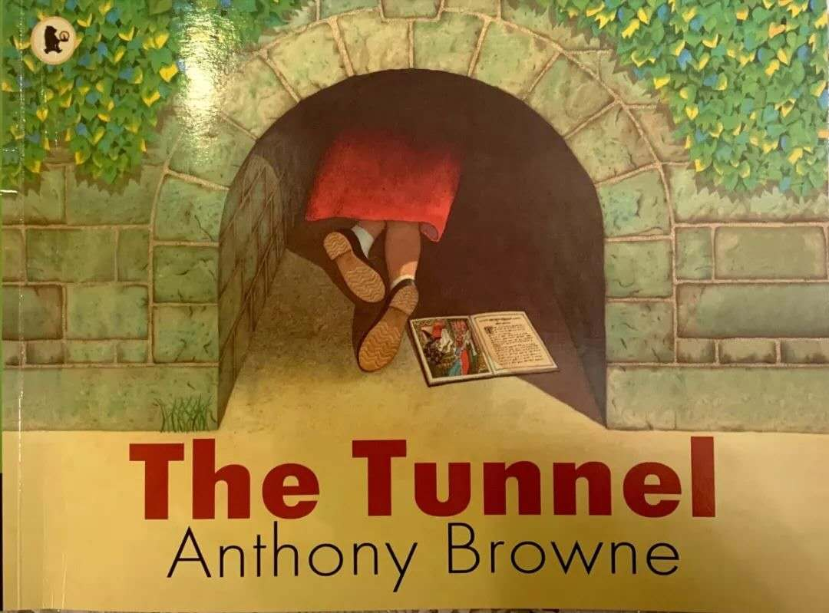

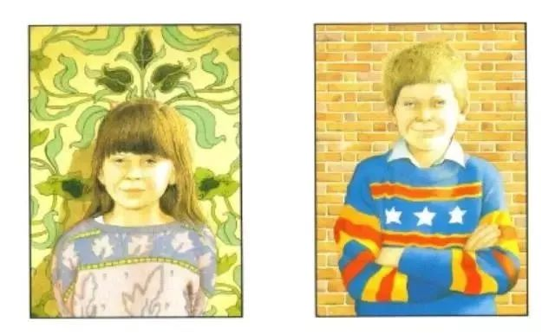

The two characters are brother and sister. The brother is naughty and brave, while the sister is a bit timid and she is a bookworm. In every way they are different from each other. At the very beginning of the story, they two quarreled a lot. They stopped quarrelling with each other until they went through the tunnel. What happened after going through the tunnel. Let’s try to read the picture book.

Here is a link of the video of the picture book available.

<https://v.qq.com/x/page/w0735r7jx0j.html>

同学们，请你点击链接体验下绘本故事带给我们的意想不到的惊喜吧！