**8年级（上）英语第30课时（第8周）**

**《爱丽丝漫游奇境记》学习指南**

**【学习目标】**

1. 能读懂谈论《爱丽丝漫游奇境记》故事梗概的文章并获取主要信息。
2. 初步运用过去进行时和一般过去时续写爱丽丝掉进兔子洞后所发生的事情。

**【学习任务】**

**任务1：你还记得《爱丽丝漫游奇境记》中人物的英文名字吗？**

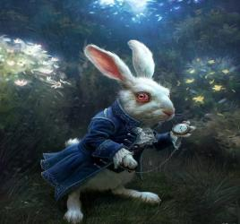

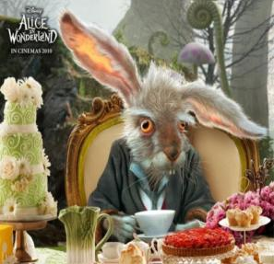

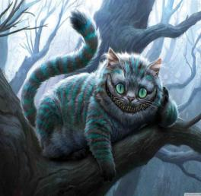

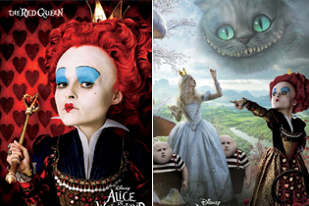

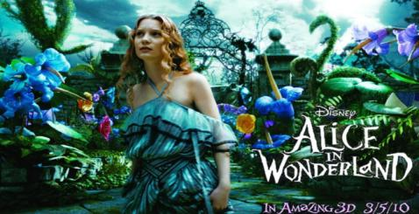

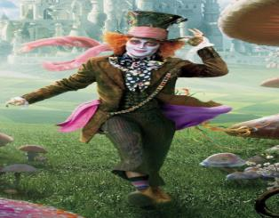

**任务2：你知道《爱丽丝漫游奇境记》的故事吗？一起跟读课文并完成下面的活动吧！**

A) Read with the recording of the passage and choose the best title（ ）:

A. Having a mad tea party B. Having a strange dream

C. Falling down a rabbit hole D. Meeting the Queen of Hearts

B) Read with the recording of the passage again and divide the passage into two parts and fill in the blanks:

Before falling down into a rabbit hole: ( ) While falling down into a rabbit hole: ( )

|  |
| --- |
| She was _______ by the river.  She________ into her sister’s book.  She saw a rabbit ____by.  (see sb do sth)  She _____across the field.  She_____ down a hole. |

|  |
| --- |
| She was ______down a very deep  hole.  She was _______ about her cat.  She _______ on some dry leaves. |

C) Read the passage and find the three strange things in the story.

A strange book:

1. What was the book like?

_________________________________________________.

1. Was Alice interested in her sister’s book? Why?

_________________________________________________.

A strange rabbit:

1. What was strange about the rabbit?

__________________________________________________.

__________________________________________________.

__________________________________________________.

__________________________________________________.

1. When did Alice think it was strange?

__________________________________________________.

A strange hole:

1. What was the hole like?

__________________________________________________.

1. If you were Alice, would you dare to jump into the hole?

__________________________________________________.

D) Write what happened to Alice by filling in the blanks. Use Activity 5 to help you. Pay attention to the words in red.

After she______ (find) a small key on a table. She_______ (open) a small door with it and saw a beautiful garden. But she _____(be) too big to go through the door. Next, she found a bottle with “DRINK ME” on it. Then she_____ (drink) from the bottle and _________(become) very small.

**任务3：读完《爱丽丝漫游奇境记》，你觉得Alice是怎样的人呢？**

———————————————————————————————————————————————————————————————————————————————————————————————————————————————————————————————————————

**任务4：**

1. Read with the recording of the passage as frequently as you can.

2. Try to write a different ending of Alice's falling down the rabbit hole.