**8年级（上）英语第29课时（第8周）**

**《回到童年》学程拓展**

Fairy tales are great memories of our childhood! There are many very classic fairy tales，such as Alice's adventures in wonderland, Snow White, Rapunzel......Here I’d like to help you review Frozen!

Do you already know the characters?

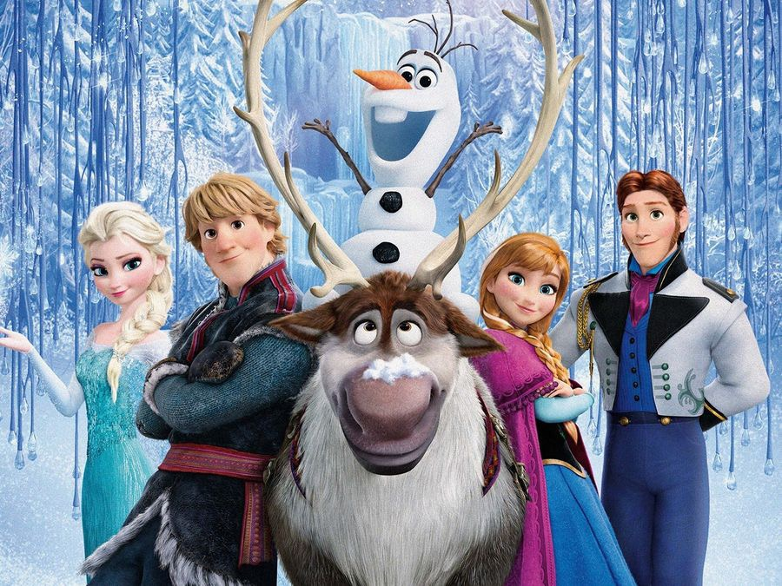

Sven

Hans

Anna

Elsa

Kristoff

Olaf

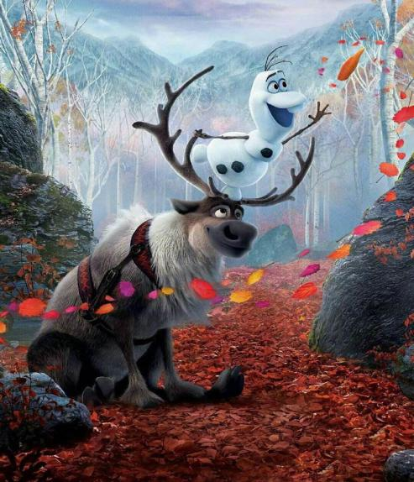

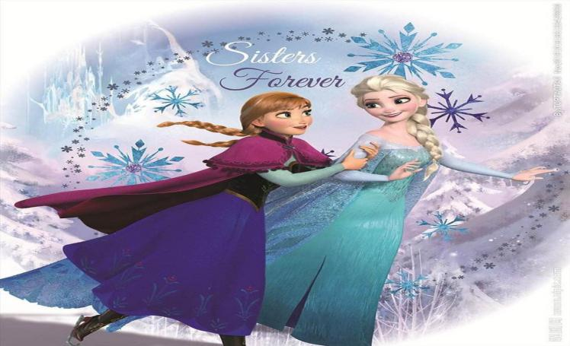

Brief introduction: The movie "frozen" tells a moving story about a kind girl called Anna helping her sister Elsa feel love in the world, and bring back the frozen summer.

Some links for you!

<https://movie.en580.com/frozen-mp4/>

<https://movie.en580.com/frozen-2/>

同学们，请你点击链接重温冰雪奇缘的经典片段，让们一起感受童话故事带给我们的美好记忆吧！