**8年级（上）英语第29课时（第8周）**

**《回到童年》学习指南**

**【学习目标】**

1. 听懂谈论《爱丽丝漫游奇境记》故事梗概的对话并获取主要信息。
2. 初步运用过去进行时复述《爱丽丝漫游奇境记》的大致故事情节。

**【学习任务】**

**任务1：童话故事是我们最美好的童年记忆，你能写出以下童话人物的英文名字吗？**

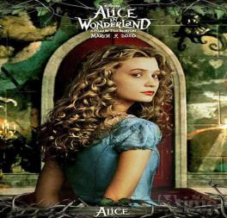

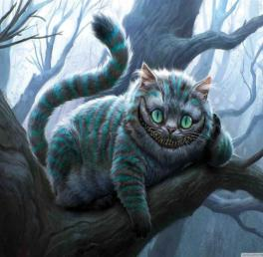

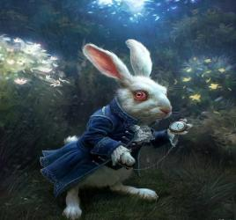

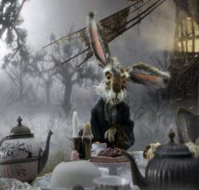





**任务2：你知道《爱丽丝漫游奇境记》的故事吗？一起听录音并完成下面的活动吧！**

A) Listen and fill in the blanks:

. She went to Wonderland and met some _____________ people and animals.

. First, she followed a white rabbit and fell down a ___________.

. Then, she saw the Cheshire Cat.

. She went to a tea party at the March Hare's _________.

. _______________, she met the Queen of Hearts.

B) Listen and number the characters as you hear them.:

The mouse ( )

The Cheshire Cat ( )

The March Hare ( )

The White Rabbit ( )

The Mad Hatter ( )

C) Listen and finish the table.

|  |  |
| --- | --- |
| Alice’s Adventures in Wonderland | It’s about a girl called Alice. |
| She was______with her______by the river.  The white rabbit with a ______ran past.  The Mad Hatter, the March Hare and a mouse were  having a______party.  The Queen of Hearts was________a strange game. |
| _________in Britain knows the story. |

**任务3：你了解《爱丽丝漫游奇境记》了吗？你能用短语或句子表达故事中的几个主要场景吗？**

———————————————————————————————————————————————————————————————————————————————————————————————————————————————————————————————————————