**8年级（上）英语第25课时（第7周）**

**《词汇大分家》学习指南**

**【学习目标】**

1. 能够通过复习英语学习方法相关词汇选择适合自己的学习建议。
2. 能够通过复习描述家乡、交通方式的形容词比较级与最高级，用英文简单表述假期旅行计划。
3. 能够通过复习动词不定式，在语境中简单使用。

**【学习任务】**

**任务1：**

1.Think about the ways to learn English and write them down on the mind-map.

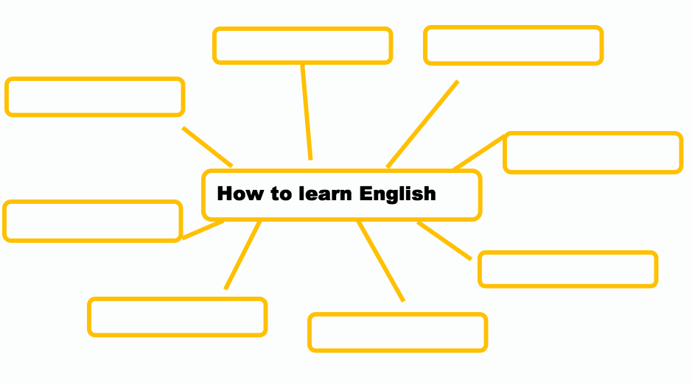

2. Write a piece of advice for yourself to learn English.

________________________________________________________________________________

Remember to write it on a piece of paper and put it on your wall!

**任务2：**

1. Complete the sentences.

1). Shenzhen is _______ than Hongkong.

2). Shenzhen’s population is _______ than the population of many other cities in China.

3). The streets are much _______ and _________.

4). Diwang Tower is _______than many other buildings in Shenzhen.

2.Write down your plan for winter holiday.

________________________________________________________________________________

________________________________________________________________________________

________________________________________________________________________________

________________________________________________________________________________

**任务3：**

1. Translate the phrases

计划做某事___________________

决定做某事___________________

想要做某事___________________

希望做某事___________________

提议做某事___________________

尝试做某事___________________

喜欢做某事___________________

学习做某事___________________

2. Translate the phrases

帮助某人做...___________________

让某人做...___________________

听到某人做...___________________

感到某人做...___________________

看到某人做..___________________

3. Complete the sentences with the correct form of the words in brackets.

1). The teacher told me _______ (clean) the blackboard.

2). I want you _______ (give) me some help.

3). His story made all of us _______ (laugh).

4). Mary decided _______ (do) her homework as soon as she got home.

5). Do you plan _______ (take) Linda out for a walk after supper?