**8年级（上）英语第22课时（第7周）**

**《国宝熊猫》学程拓展**

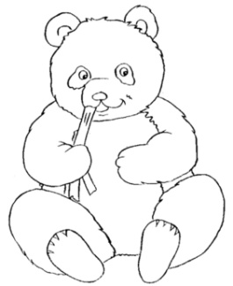 The giant panda is a well-known species that is being driven to extinction by habitat loss. It has become one of the most endangered mammals in the world, with only 1,600 of them left. Although they have been protected from hunting and on the Endangered Species list since 1984, pandas are still disappearing.

Their problem is complex. The giant panda eats bamboo and only bamboo. There is so little nutrition in bamboo that they have to eat for more than 14 hours a day to get the calories they need. They eat 13 to 36 kilograms of bamboo parts a day. Without a bamboo forest on which to feed, all the pandas will die.

Giant pandas are found only in southwestern China. China has one of the most populated countries in the world. There are more people here every year. To house and feed themselves, they cut down forests for farms and communities, including the shrinking bamboo forests. Sometimes, pandas are left in small islands of bamboo surrounded by houses and highways. Worse yet, sometimes bamboo will die off and the pandas will have to go in search of a new bamboo forest -- if there is one. Unless all destruction of the bamboo forests stop soon, there will be no more panda habitats and then no more pandas.

**Answer the questions:**

1. What was done to protect giant pandas in 1984?

________________________________________________________________________.

1. What is the giant panda’s only food and why do they need to eat so much of it?

________________________________________________________________________.

1. Why is protecting the giant panda’s food so hard to do?

________________________________________________________________________.

1. What will happen if we cannot protect the giant panda’s habitat?

_________________________________________________________________________.

1. What’s the amount of food pandas need daily?

__________________________________________________________________________.