**8年级（上）英语第21课时（第7周）**

**《濒危动物知多少》学习指南**

**【学习目标】**

1. 能够提取音频中有关盘羊和雪豹两种濒危动物的细节信息，比如栖息地、数量、外貌特征、食物以及濒危的主要原因；
2. 能够从WWF、政府、学生三个角度简单谈论如何保护濒危动物。

**【学习任务】**

**任务1：Label the endangered animals.**

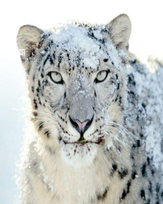

**panda**

**snow leopard**

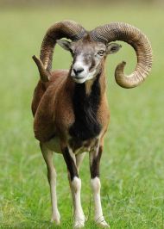

**Argali sheep**

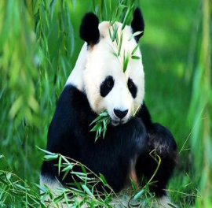

**polar bear**

**white tiger**

|  |  |  |  |  |  |
| --- | --- | --- | --- | --- | --- |
| **Endangered**  **Animals** | **Habitat** | **Numbers** | **Appearance** | **Food** | **Threats** |
| **Argali sheep** | **deserts**  **and rocky areas in northern Asia** | **less than**  **_____________** | **large________horns;**  **_________long legs** | **_________** | **_____________** |
| **snow leopard** | **the _____________**  **of central Asia** | **in the wild:**  **3,500~_______;**  **in zoos:**  **600~700** | **beautiful and thick fur with black________;**  **light green or gray eyes** | **wild goats, sheep and ________** | **1. ______________**  **2. habitat________** |

**任务2：Listen and fill in blanks.**

**任务3：Match the groups with their actions.**

* **W**ild **W**orld **F**und improve regulation and monitoring of hunting
* The government work in a conservation organization as a volunteer
* Students establish national parks and wildlife reserves around the world

**Homework：Write down your speech draft.**

Suppose you have been hired by the newly created ENDANGERED ANIMAL PRESERVATION LEAGUE(濒危动物保护联盟) in your city. As part of their educational campaign, you are going to address a speech about a specific endangered animal, in an effort to educate the public.

Your speech **must** include:

* Basic information on the specific endangered animal (e.g. appearance, habitat, food, number, etc.)
* The reasons why it is endangered.
* Possible ways that can help to preserve it.

Possible speech draft:

_____________________________________________________________________________________________________________________________________________________________________________________________________________________________________________________________________________________________________________________________________________________________________________________________________________________________________________________________________________________________________________________________________________________________________________________________________________________________________________________________