**8年级上英语第15课时（第4周）**

**《揭秘英语之“最”》学程拓展**

**阅读：请同学们阅读下面的两则新闻，了解关于交通工具的最新资讯吧！**

**The world's first fully electric plane has flown successfully for almost 15 minutes.**

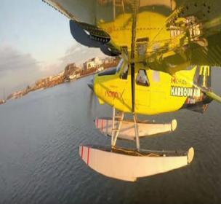The world's first fully electric commercial aircraft took its inaugural(创始的) test flight on Tuesday, taking off from the Canadian city of Vancouver and offering hope that airlines may one day end their polluting emissions(污染排放)."This proves that commercial(商业的) aviation(航空) in all-electric form can work," said Roei Ganzarski, chief executive of Seattle-based engineering firm magniX.  
 The company designed the plane's motor and worked in partnership with Harbour Air, which ferries half a million passengers a year between Vancouver, Whistler ski resort and nearby islands and coastal communities.Ganzarski said the technology would mean significant cost savings for airlines -- not to mention zero emissions."This signifies (预示) the start of the electric aviation age," he told reporters.Civil aviation is one of the fastest growing sources of carbon emissions as people increasingly take to the skies and new technologies have been slow to get off the ground.At 285 grammes of CO2 emitted per kilometre (mile) travelled by each passenger, airline industry(工业) emissions far exceed（超过） those from all other modes of transport, according to the European Environment Agency. The emissions contribute to global warming and climate change, which scientists say will unleash（突然释放） ever harsher droughts, superstorms, and sea-level rise.The e-plane -- a 62-year-old, six-passenger DHC-2 de Havilland Beaver seaplane retrofitted（翻新，改型） with an electric motor –- was piloted by Greg McDougall, founder and chief executive of Harbour Air."For me that flight was just like flying a Beaver, but it was a Beaver on electric steroids. I actually had to back off on the power," he said.McDougall took the plane on a short loop along the Fraser River near Vancouver International Airport in front of around 100 onlookers soon after sunrise.

**Huawei may launch its own self-driving car in 2021**

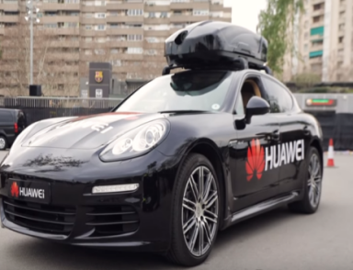Huawei has hit the headlines several times over the last few months - and not for the best reasons.The tech giant’s smartphone business took a huge knock, after Google revealed(透露) that it was blocking( 阻碍) Huawei from using several apps, as well as its operating system, on its phones.  
 Following the news, it seems that Huawei is looking at its other options beyond smartphones, and could even launch(发行) its own self-driving car.Speaking to the Financial Times, Huawei revealed plans to launch a self-driving car as early as 2021.  
 Dang Wenshuan, Huawei’s chief strategy architect, explained that Huawei is working with both Audi and Toyota to develop the vehicles.He said: “From my understanding, we are working together to have a car that will be shipped in the year 2021 or 2022 using these [autonomous driving] components."This will be in China, but not only in China...it will also be in Europe.”Mr Wenshuan added that the self-driving cars are likely to launch first in China, as car manufacturers(生产商) there are moving faster.’  
 However, if Huawei does launch its own self-driving car, it’ll face stiff competition from several other tech giants.Google and Uber are just two of the big brands(品牌) racing to get their self-driving cars on the streets.