8年级英语第15课时（第4周）
《揭秘英语之“最”》学习指南
【学习目标】
- 能够梳理形容词、副词最高级的用法，常见句型及形容词、副词最高级的变化规律。
- 能够正确使用形容词，副词最高级描述或比较不同的交通工具。
【学习任务单】
任务一：请观看微课前，猜猜以下谜语的谜底。
1. What's the longest word in the world? _________________
2. Why is the library the highest building? _________________
3. What's the poorest bank in the world? _________________
4. What season is the most dangerous? _________________
任务二：请观看微课，并回答以下问题。
1.当我们要将______________ 事物进行比较时，可以用形容词或副词的最高级形式来表达。
2.用形容词或副词的比较级与最高级的区别在于_______________________________.
3.形容词、副词最高级常见句型有：(1) _________________最...之一 (2) _________________第几...
4.形容词、副词最高级的变化规则为：
 |  | 构成方法 | 举例说明
规则变化 | 单音节和少数双音节单词 | 一般在结尾加__________
规则变化 | 单音节和少数双音节单词 | 以e结尾的词直接加________
规则变化 | 单音节和少数双音节单词 | 以重读闭音节结尾的词，如结尾只有一个辅音字母，________
规则变化 | 单音节和少数双音节单词 | “辅音字母+y“结尾的单词，________
规则变化 | 大部分双音节和多音节单词 | 在单词前加________
不规则变化
任务三：请观看微课，并完成以下练习。
- 请选择正确答案。
(1) -Of all your classmates, who runs _________ ? -Mike. He keeps running every day.
A. faster B. more slowly C. fastest D. most slowly
(2) Huawei is one of _________ companies in the world.
A. large B. larger C. largest D. the largest
(3) I think my school is much ______ than yours.
A. big B. bigger C. biggest D. the biggest
(4) Which subject do you think is ________, English or Chinese?
A. easy B. easier C. easiest D. the easiest
(5) I often go to school by bike and I think it’s _______way to get there.
A. good B. better C. best D. the best
2.请写出下列形容词或副词的最高级。
(1) long- ________ (2) close-_________ (3) short-_________ (4) hot-_________ (5) early-________
(6) dangerous-____________ (7) bad-________ (8) little-________ (9) hard-________(10) happy-____
3. 请看图片，完成下列句子。
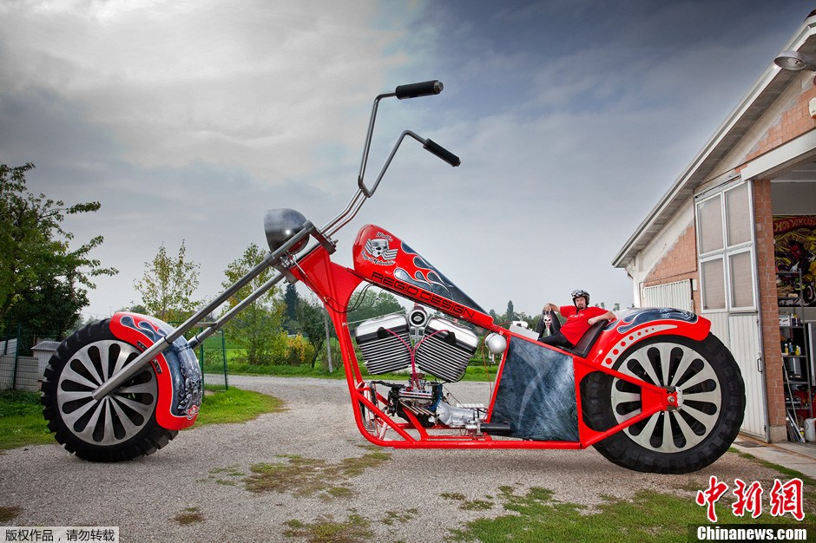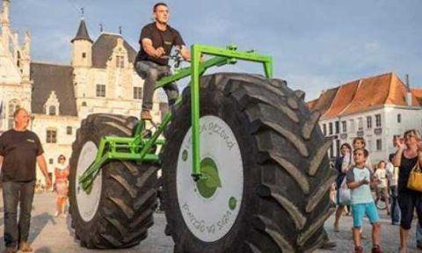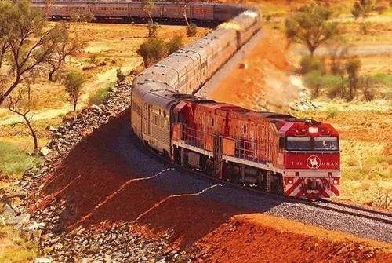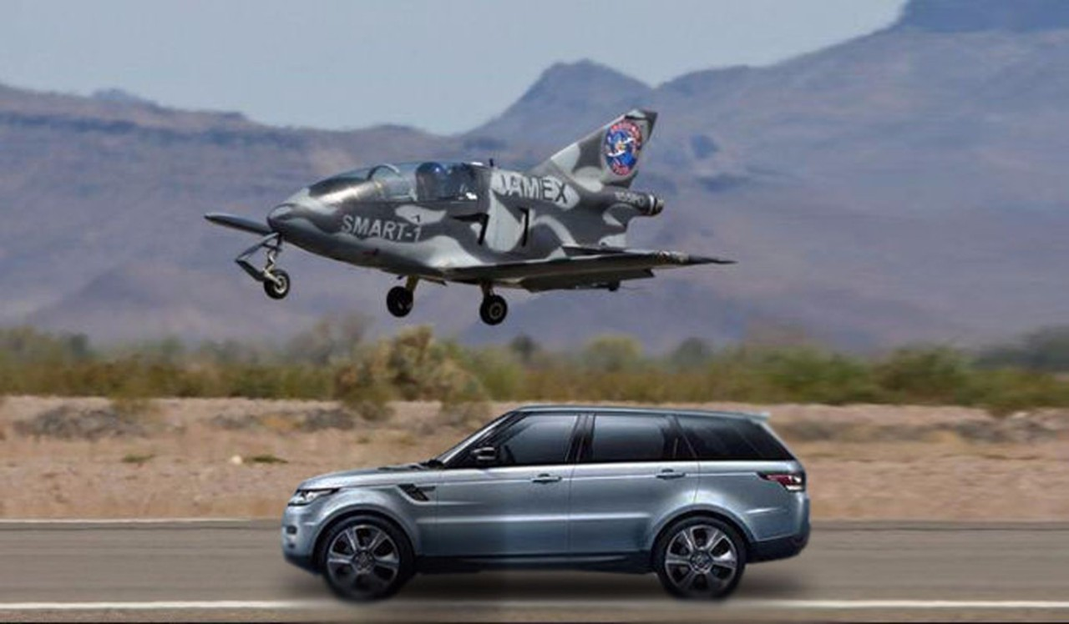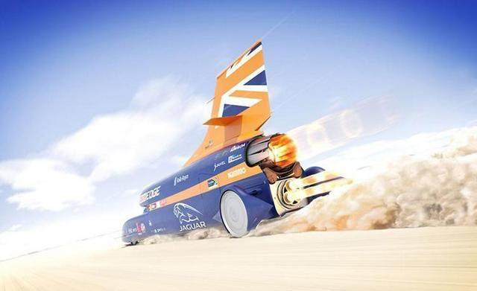
- （2） （3） （4） （5）
- The man is sitting on ___________ (high) motorbike in the world.
- The man is riding ___________ (heavy) bicycle in the world.
- Australia has __________ (long) train in the world.
- Jim Bede designed ___________ (small) plane in the world.
- Bloodhound is the car running __________ (fast) in the world.

4 请看图片，完成下面句子或对话。
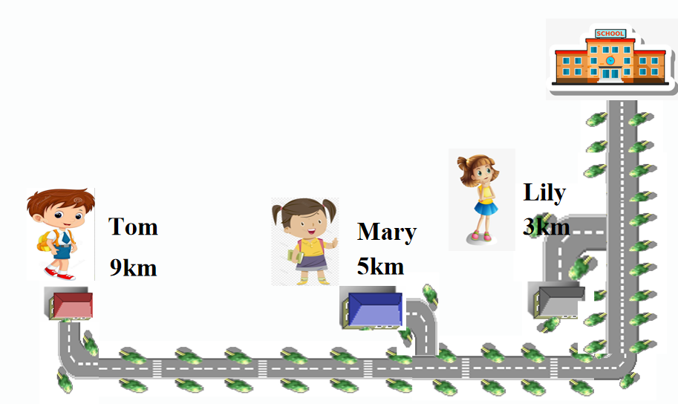
(1)Lily lives ___________ to school.
(2)Tom lives _____________ from school.
(3) Lily goes to school by bike, because it is ____________way.
And it is good for my health.
(4) Mary goes to school by car, because it is ______________
and ____________ way. But it is the most expensive.
(5)Tom goes to school by underground, because it is
________________way. And there is no traffic jam.

5.假如你是琳达，十一假期就要到了，你的好朋友朱迪和他的父母打算从上海来北京游玩，就出行方式询问你的意见，请你查询相关资料，回复信息，帮她从不同方面比较不同交通方式的利弊。
Hi, Linda! My family and I are planning a journey from Shanghai to Beijing during the National Holiday. How can we get to Beijing? What is the best way to travel? Could you please give me some suggestions?


Hi, Judy! I'm glad to help you! A journey by__________ is the___________________. But__________________________ .You can also take a _____________________ . Because it is _________________ .And it will take you ___________. The third choice is by ______________. _______________________________ __________________________I hope this helps! Have a great trip!



