**《发展前滚翻能力练习1》学程拓展**

**可参考相关指导书籍进行练习：**

**《中小学体育教材教法与学法指导的应用小学体操分册：第二章　技巧》**

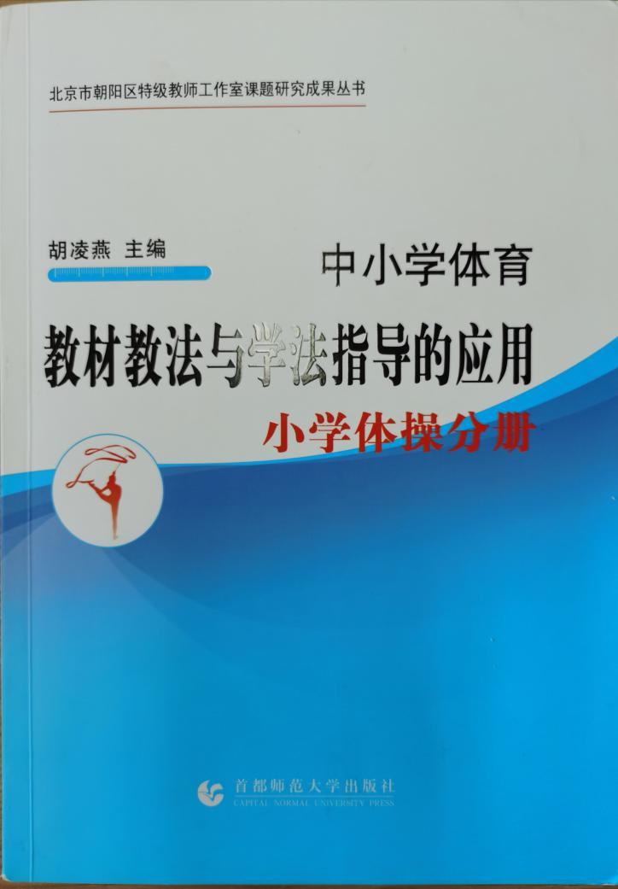

**也可在百度中搜索“各种前滚翻的练习，对照视频进行练习，如：**

https://m.baidu.com/video/page?pd=video_page&nid=10919603011365584596&sign=5698865921998207370&word=%E6%96%9C%E5%9D%A1%E5%89%8D%E6%BB%9A%E7%BF%BB&title=%E6%A9%99%E6%98%9F%E7%BA%A72-1%E5%89%8D%E6%BB%9A%E7%BF%BB%28%E6%96%9C%E5%9D%A1%E5%9E%AB%29&atn=index&alr=1&openapi=1&resource_id=5052&frsrcid=4185&cambrian_id=1636825297978304&baijiahao_id=&sp=0&ext=%7B%22src%22%3A%22https%3A%5C%2F%5C%2Fvdse.bdstatic.com%5C%2F%5C%2F055ae374d9c1718101cfa83ce9c49416.mp4%3Fauthorization%3Dbce-auth-v1%252F40f207e648424f47b2e3dfbb1014b1a5%252F2020-07-27T17%253A20%253A40Z%252F-1%252Fhost%252F76018727ea81e0dcd21cb6c96912fd242c95fc0f90435bc0a7f581abc0f1688a%22%2C%22loc%22%3A%22http%3A%5C%2F%5C%2Fv.youku.com%5C%2Fv_show%5C%2Fid_XMzI1NTk2ODMyOA%3D%3D.html%22%2C%22log_loc%22%3A%22https%3A%5C%2F%5C%2Fv.youku.com%5C%2Fv_show%5C%2Fid_XMzI1NTk2ODMyOA%3D%3D.html%22%2C%22duration%22%3A15%2C%22poster%22%3A%22%22%2C%22source%22%3A%22%5Cu4f18%5Cu9177%22%2C%22s%22%3A%224fc5a291ae508fd21bb2c993d2c599d2%22%2C%22isHttps%22%3A1

**通过参考书籍和网络视频练习后，学生可尝试自行研发新动作进行练习。**