8年级英语第13课时
《交通方式大比拼》学习指南
【学习目标】
- 能够听懂常见的交通工具的英文。
- 能够正确使用形容词的最高级推荐出行方式。
【学习任务单】
任务一：请在观看微课前，观看拓展资源中的视频并记下其中的交通工具。
____________ ____________ ____________ ____________ ____________ ____________
____________ ____________ ____________ ____________ ____________ ____________
____________ ____________ ____________ ____________ ____________ ____________
____________ ____________ ____________ ____________ ____________ ____________
____________ ____________ ____________ ____________ ____________ ____________

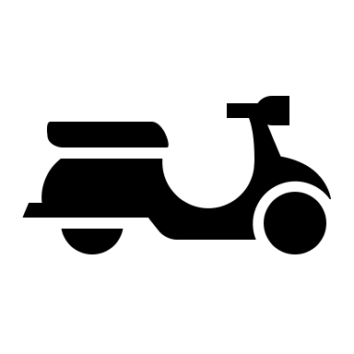

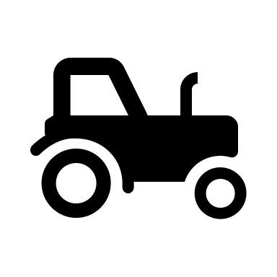

任务二：请观看微课，并回答以下问题。
How do we call them?
______________________________________________________________
- What are the three means of transportation in ancient time?

- What do we develop in modern society?

- What are the three types of transportations in modern society?

任务三：观看微课，并完成以下练习。
- 看视频，完成表格1。可以使用缩写
做出你的总结吧：eg. Bike is the cheapest of …
________________ is the ______________ of _________ transportation.
________________ is the ______________ of _________ transportation.
________________ is the ______________ of _________ transportation.
________________ is the ______________ of _________ transportation.
- 看视频，完成表格2.
做出你的总结吧：eg. Bike is the cheapest of …
________________ is the ______________ of _________ transportation.
________________ is the ______________ of _________ transportation.
________________ is the ______________ of _________ transportation.
________________ is the ______________ of _________ transportation.
- 进阶挑战：看视频，完成表格并复述。把音频发给你的老师获得一个分数吧！
- 你心中还有哪些奖要颁给日常陪伴你的交通工具吗？来说说理由吧！

________________________________________________________________________________________
________________________________________________________________________________________
________________________________________________________________________________________
________________________________________________________________________________________

