8年级英语第14课时
《出行方式谁最强》学习指南
【学习目标】
- 能够通过阅读网上搜索到的不同旅行方式信息，能够对比分析其利弊，选出最佳方案。
- 能够正确分析文中形容词、副词的最高级并比较不同的出行方式。
【学习任务单】
任务一：请观看微课前，请回答并完成下面的小问卷。
- Are you a travel-lover?
____________________________________________________________________
- Where do you plan to travel to on your holiday?
____________________________________________________________________
- How many ways are there to travel and what is the best way?
____________________________________________________________________
- Look at the map of England and France, find and circle the capitals of the two countries.
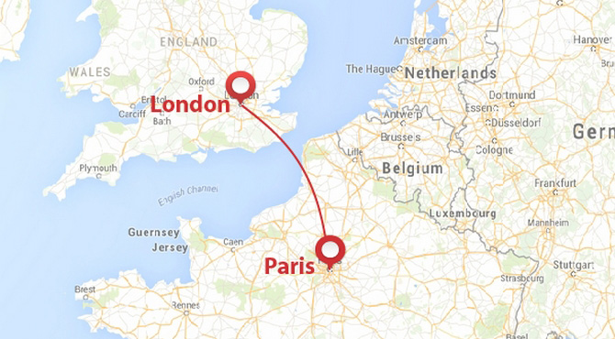

the English Channel: 英吉利海峡

任务二：请观看微课，并根据微课内容用形容词或副词的正确形式补全信息。
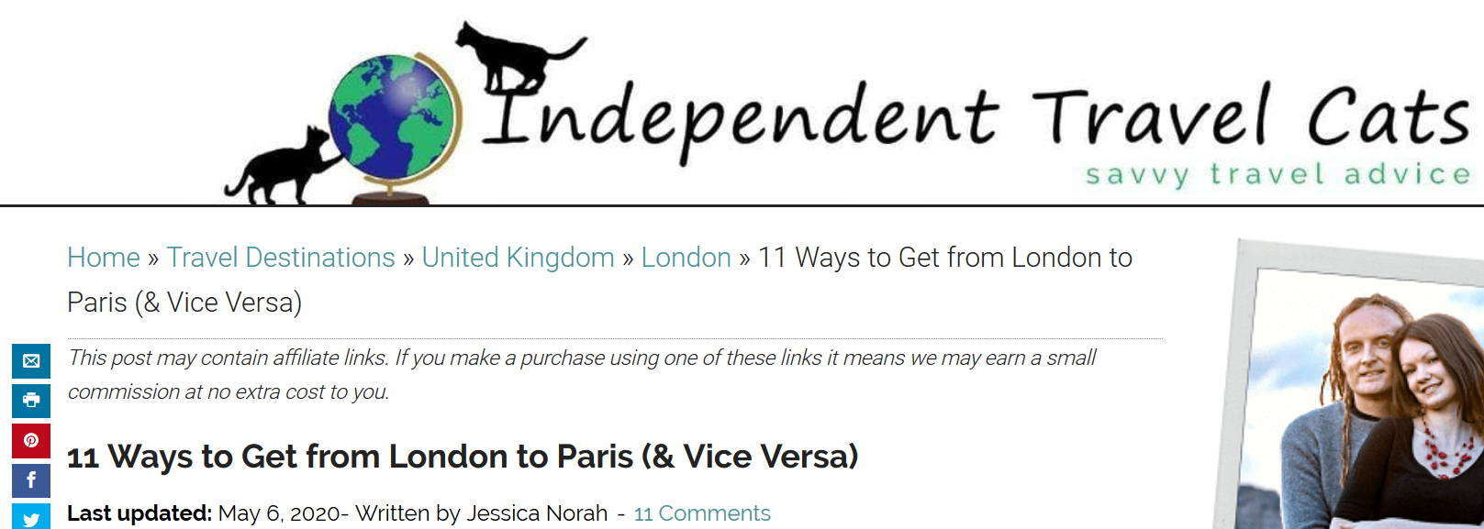
How to get from London to Paris:
1. Eurostar Train
This is perhaps the (easy) way to get from London to Paris and is usually our recommended way to travel between the two cities. The Eurostar is cost-efficient with tickets starting at $62, and it is very fast, sometimes even than flying.
2. Flying
Flying is another popular way to get between London and Paris because it is the (quick) mode of transportation. And flights between the two cities are often (用cheap的同义词). But going through security and boarding procedures take some time, therefore, it may be more time-efficient to simply take the train.
3. Car / Driving
Driving from London to Paris gives you a certain amount of flexibility because the timetable is
(flexible) way.
4. Bus / Coach
Taking a bus from London to Paris is usually the (little)expensive transport option.
The (popular) bus companies that service this route are Flixbus and BlaBlaBus.
Flixbus is (large) bus network in Europe. BlaBlaBus is the bus company that offers (cheap) tickets to get from London to Paris with fares starting at just $18.
任务三：请观看微课，并完成以下练习。
1.请帮James完成出行方式对比表格。
Modes of transportation | cost | Advantages | Disadvantages
Eurostar Train | ≥$62 | - way  - Sometimes than flying  - The most way
Flying | ≥$56 | The way | taking time for security and boarding procedures
Car/Driving | ≥£79 | - The best way to  - The most way | taking a long time  expensive
Bus / Coach | ≥£18 | The way | taking a long time
2.请思考并回答以下问题：
(1) After comparing the advantages and disadvantages of different ways from London to Paris, James finally decides to take the . James chooses the best way depending on what suits him best.
(2) Imagine: if you were James, how would you choose and why?
If I were James, I would choose to because
.
任务四：如果你假期准备从北京出发旅行，你准备去哪里呢？去那里旅行都有哪些方式呢？对你来说最佳方式是什么？请你查询相关资料，对比不同出行方式的利弊，并写出最佳出行方案。

You may use sentence like this:
For my next holiday, I’m going to travel to...because...
After searching online, there are ways to get from Beijing to .
To go there by... is the cheapest way because...
The most...way is to ....because it gives you a certain amount of flexibility
.... is another popular way to get between... and... because it is the quickest mode of transportation.

.

