
8年级上英语第16课时
《我的旅行攻略--出行方式篇》学程拓展
生活在大都市，堵车无时无刻不困扰着我们，大家一定都在幻想着要是没有堵车生活会有多美丽。今天给大家介绍两种出行方式，在未来，也许真的会让你出行无忧。
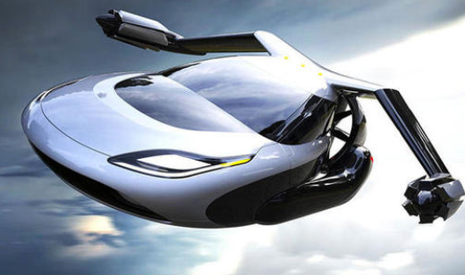
The flying car
Humans have always dreamed of finding a way to leave traffic jams(交通堵塞）behind.
Well,dream no longer.The flying car can help cut down on traffic jams.
The world's"first flying car",called the Terrafugia Transition,has made its first flight in the skies of the US.It can fly 640 km through the air without adding more gas,the car maker. Terrafugia Inc.,says.
As a light airplane,it is not easy for the Terrafugia Transition to fly in poor weather.
However,it has the advantage of being able to continue the journey by road if conditions take a turn for the worse.
This is the first proven flying car with foldable wings.These allow it to perfectly transfer from air to road.

The pod car
For those afraid of heights,or who don't want to fly,the pod car(豆荚车) is a great way to travel.
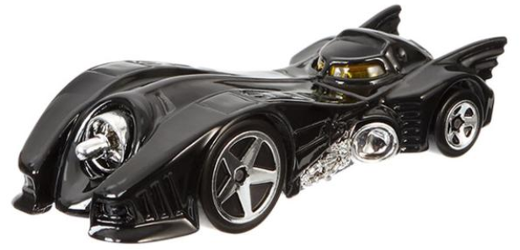
Imagine using a button to stop the small pod-shaped car.The doors open,you climb into the passenger seat,and enter your personal number.Minutes later,the doors slide open and you have reached the place where you're going.
Cities around the world are looking into pod-car systems,as pod cars do not need human drivers.They are designed for one person or small groups traveling together.Passengers simply type their place into the pod car's computer and the pod car takes them directly there.
Because pod cars do not make unnecessary stops and use electricity,they save a lot of energy and do not pollute the air.Pod cars also provide passengers with faster service and more privacy than a subway or a bus.
While flying cars and pod cars may be a dream unavailable to now,many humans are still dreaming bigger dreams,such as teleportation(瞬间位移术）.It is most widely found in works of science fiction.
Teleportation is a method of transportation,in which.objects or information are dematerialized(使消失），and then recreated in another place.Maybe one day, teleportation could become a reality and people could avoid traffic jam for ever!

